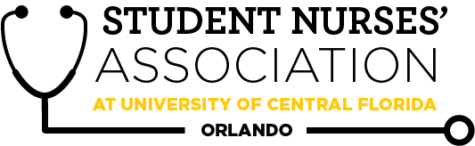 |  | Student Nurses’ Association at UCF Orlando –  June Board Meeting Minutes (06/03/2026)  Time Called to Order: 3:03 PM  Time Adjourned: 5:43 PM  Location: CON Lobby  Presiding President: Hallie Schroeder  Recorded by: Gabby Valdez
Attendees Present: | Hallie Schroeder, Briana Dattile, Ivy Yego, Lucy Bisceglia, Brooke Sanders, Alexandra Duran, Chiazoka Ozougwu, Samantha Boles, Brian Peach, Linda Foley
Attendees Absent: | Adriana Sullivan, Miguel Salgado Varela, Kathy Ngyuen, Briana Dattile
Presenter: | Agenda Item/Discussion: |  | Action: | Follow-up:
President:  Hallie Schroeder | Important updates:  - Ice Breaker ❄️: What is one summer hobby that you plan to try this summer or one that you would like to learn in the future?  - The planning of Diamond Chapter and our state convention has begun!  - Ivy, Lucy, and I have met and are beginning to get the details in order for funding purposes (woo!)  - Super successful May GBM! Over 60 RSVPs and the accels all seemed engaged and eager to come back.  - Elections coming up soon so promote, promote, promote! |  | - VOTE: Hallie  makes a motion to  propose a change to Bylaw Article VII, Section 1E from "Each general meeting will include a speaker of interest." to "At least 50% of general meetings will include a speaker of interest."  and this will be voted on in our GBM in June.  Alex seconds. Motion Passes. | - No follow-up needed
Vice President:  Briana Dattile & Nick Maiorino | Important updates:  - June: Tuesday, Feb 24th (5:00-7:30 PM)  - Speaker: Possibly Eliany Pon?  - Food: need help with ideas!  - Icebreaker: Kahoot  - Sign up for GBM roles  - Food pick-up role: ______  - Zoom communication w/ members role: ______  - No July GBM!  - Nick make new VP goals |  | - No action needed | - No follow-up needed
Legislative Director:  Lucy Bisceglia | Important updates:  - 3 pre-slated Accel. Liaison spots  - 1 pre-slated Merch. Director spot  - Finalizing the constitution before sending it for review by the RSO officers  - Picked a resolution topic!  - A personal choice, I want to promote educating K-12 teachers who have Type 1 Diabetic students in their class to improve classroom safety, support appropriate CGM/phone access, and ensure prompt recognition and treatment of hypo/hyperglycemia.  - Title: Promoting Educator Competency in Pediatric Type 1 Diabetes Recognition and Management  - Per the OSI, we are now required to notify them of officer changes within 10 days, so deciding if that is a president or leg. director task and adding it to the bylaws?  - I emailed OSI asking them how to access the specific form and waiting to hear |  | - No action needed | - No follow-up needed
Treasurer:  Ivy Yego | Important updates:  - Current Bank Balance: $11,222.59  - Current Membership Count: 158  - Financial Excellence Award → Goes to Chapter, NOT individual  - For future scholarships → inform all officers about whether it’s for them or chapter/school  - Accel Cohort Decision → 6 people need refunds (we haven’t gotten funding from the grant) → Should we just go through with it to minimize them waiting? $342  - Vote?  - Shipping Issue with products on Square (applied to some memberships as well)  - Emailed NSNA’s Membership Processing Dept. → still waiting on a response (might need to contact someone else)  - Finished April’s Financial Document but…  - Financial Documents can no longer be bulk signed with Dropbox Sign for free (capped at 3 signatures)  - 1) Free Option: OpenSign  - 2) Free Option: Handwritten Signatures  - 3) Convenient Option: Dropbox Sign → $15/mo (special right now for $13.50)  - Reimbursements v. Credit Card  - I would like to propose the alternative of me purchasing items/necessities/essentials instead of reimbursements  - Benefit of no longer waiting for reimbursement if board approval is needed (when >$100)  - Benefit of one less thing for you to do  - Benefit of early planning b/c you would have to let me know in advance, with a provided deadline of when the payment would need to be made  - Vote needed on this suggestion  - Vote on Reimbursing Bri cost of the Domino’s order  - $179.77  - Vote on Board Budget  - Emailed students who have upcoming or overdue membership renewals  - Friendly Reminders:  - 2 officers at the cashbox at all times except for the treasurer  - All officers can accept membership forms  - Must provide a receipt to the treasurer whenever spending SNA funds or for reimbursement  - Reimbursements < $50 need president's approval  - Reimbursements > $50 need board approval  - Bank card must be signed in and out to use it  - Every purchase made with the SNA card requires a receipt to be sent to the treasurer within 48 hours of purchase  - Separate SNA purchases and personal purchases (make 2 separate transactions) |  | VOTE: Ivy makes a motion to refund 6 accel students $57 each for a total of $342.  Miguel seconds.  Motion passes.  VOTE: Ivy makes a motion to refund Bri $197.77 for last month's GBM.  Sami seconds.  Motion passes.  VOTE: Ivy makes a motion to change the annual budget to $4975. Sami seconds.  Motion passes.  VOTE: Ivy makes a motion to ensure that the UCF SNA Orlando chapter’s annual financial audit is complete at the end of each fiscal year. The audit should be reviewed and signed by the SNA Board. Lucy seconds.  Motion passes. | - No follow-up needed
Secretary:  Gabby Valdez | Important updates:  - Vote on May’s meeting minutes |  | - VOTE: Gabby  makes a motion to  approve May’s  2026 board meeting  minutes.  Hallie seconds.  Motion passes. | - No follow-up needed
Community Health Director:  Angelia Salazar | Important updates:  - RMDH june 19th  - Planning on gathering food items/ budgeting for event  - 7 members in total all Accels!  - Email sent about possible blood drive with College of Medicine |  | - No action needed | - No follow-up needed
Fundraising Director:  Chiazoka Ozougwu & Kathy Nguyen | Important updates:  - June fundraiser (Owala raffle) is still being finalized. Currently working on creating a submission form that does not require a payment option. Once the form is finalized, promotion and raffle details will be shared!  - Planning a Raising Cane’s Partial Proceeds Night for next month. Coordinating event logistics and awaiting confirmation of details. |  | - No action needed | - No follow-up needed
Media Director: Samantha Boles | Important updates:  ★ Newsletter:  - August  - Welcome the school year  - Externships  - Vacations  - Research class  - Send our sign up sheet  ★ Website:  - Taking FOREVER! (Seriously, I've spent hours!)  - It is awful. Like there are links on that website from 2014 that are not even active.  ★ LinkTree:  - I have updated all of the links on the platform aside from the committee interest form for the 2026-2027 year.  ★ Social Media:  - Posts:  - GBM posts (monthly)  - Merch promos NEED PHOTOS OF PEOPLE WEARING MERCH!!  - Monthly Calendar with SNA events  - Send flyers out to cohorts (designate one person from each cohort to send out info through canvas)  ★ Sheets:  - Create a Google Sheet with all interaction information.  ★ TikTok:  - Unable to be recovered :(  - Will have to make a new account  - I have contacted support and have not heard back yet |  | - No action needed | - No follow-up needed
Historian:  Adriana Sullivan | Important updates:  - Unable to attend due to being at work :(  - I emailed Dr. Radecki for updates regarding schedules so that I may pick a date for the barbecue  - I will be attending the UCF alumni volunteer conference with UCF nursing alumni on June 6th  - Afterwards, I will be reaching out to them regarding supporting us at the barbecue  - I will be using Sonnys barbecue again for the BBQ  - I would like to do a raffle at the barbecue, so I am thinking of maybe raffling off a tote bag, and we could do raffle tickets for either $1-$5. Let me know your thoughts in the comments! And then the money raised would go towards our bank account balance |  | - No action needed | - No follow-up needed
Breakthrough to Nursing Director: Miguel Salgado Varela | Important updates:  - Regarding the previously mentioned event that I was planning to make at Colonial High School, I have communicated to my contact that it would be a better idea to make it during the fall as we decided during the last meeting. I am yet to receive a response from them, but I will try to reach out again during this month.  - I have an email prepared to be sent to Mrs. Judy Rechsteiner regarding the Mentor-Mentee program to share the sign up form for the upcoming cohort. I have already prepared the email that I am sending to the students, and in the following weeks I will find a proper match for each student.  - I have prepared an email for the new APNS advisor, Ms. Darcy Ravndal, mentioning that SNA is looking to collaborate with them for the upcoming semester. I would like suggestions on ideas of what we could plan with APNS.  - It has come to my attention in the past few days that Dr. Peach and Community Health Director, Angelia, have been communicating with representatives of OCPS. I am still unaware of the full context of the situation. Thank you both for working on this. |  | - No action needed | - No follow-up needed
Accelerated Liaison:  Alexandra Duran | Important updates:  - Accel mentor-mentee program finalized, all 46 mentees are paired  - June 24th - possible meet & greet. Will an advisor be available to attend?  - Planning to send a poll to determine student attendance for the Meet & Greet.  - Working on identifying the top point earners for students graduating in August 2026.  - Working on Accel grad video  - Do we have updated instructions/guidelines, or should I follow the Spring semester format?  - Started creating a handoff document for the incoming Accel Liaison (2027).  - XXS, XS, S scrub donations are still available  - Working on obtaining a headcount for graduation cord pre-orders. |  | - No action needed | - No follow-up needed
Merchandise Director: Brooke Sanders | - Merch order  - We cannot use “UCF” or logos. If we want to use UCF, it has to be preceded by “SNA.” Ex: SNA at UCF  SOLD OUT  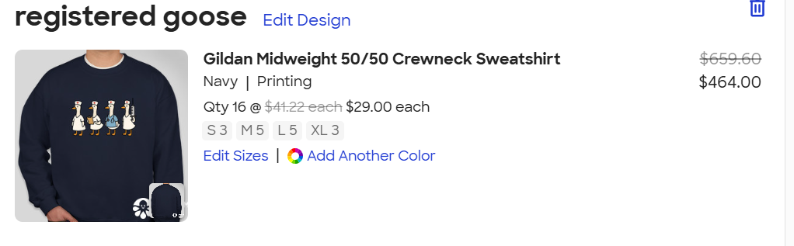  ONLY 4 MEDIUM  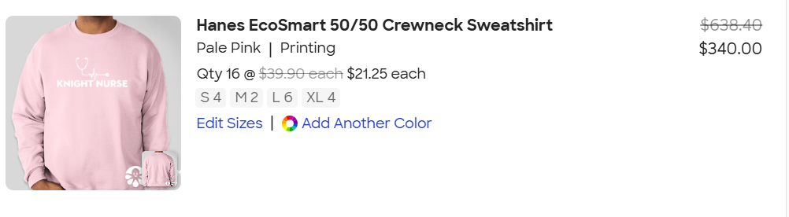  ONLY 2 LARGE AND 1 XL  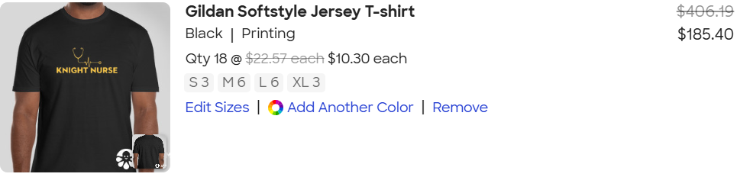  NONE BUT HOODIE COULD BE GOOD OPTION?  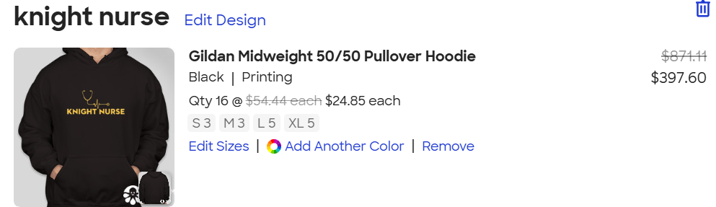  TOTAL FOR ALL (we dont have to buy all)  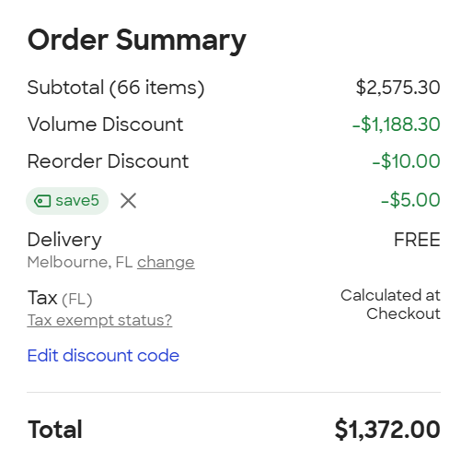 |  | - VOTE: Brooke makes a motion to order the merch totaling around $1400. Hallie seconds.  Motion passes. | - No follow-up needed
Advisors:  Kate Dorminy  Brian Peach  Linda Foley | Important updates:  - No agenda |  | - No action needed | - No follow-up needed

