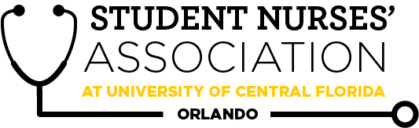 |  | Student Nurses’ Association at UCF Orlando –  March Board Meeting Minutes 3/3/2026  Time Called to Order: 1611 PM  Time Adjourned: 1746 PM  Location: CON Lobby  Presiding President: Allyson Crighton  Recorded by: Ciaera Ambroise
Attendees Present: | Allyson Crighton, Hallie Schroeder, Briana Dattile, Nicholas (VP-elect), Aiya Falhi, Ivy Yego, Cieara Ambroise, Madeline Sink, Lucy Bisceglia, Ronica Bukasa, Willow Bynum, Brooke Bynum, Marion Jones, Kate Dorminy, Brian Peach, Linda Foley, Kathy (elect)
Attendees Absent: | Chiazoka Ozougwu, Brooke Sanders, Alexandra Duran
Presenter: | Agenda Item/Discussion: |  | Action: | Follow-up:
President:  Allyson Crighton | Important updates:  - NSNA Awards and LeadershipU applications are complete.  - DSSO Classification Application - approved.  - We can now use UCF merchandise logos, but we should consult with the vendors and send proof of DSSO as needed. Maybe order merch once we recount inventory after tomorrow's event.  - VP Elect & Treasurer Elect Badges have arrived  - Brooke & Willow will be picking it up from TheSpot at UCF.  Current Activities:  - Pre-order form for SNA cords:  - Current cord count: 10 in one color  - Current stole count: 4 (need 8 total?); appx $220 will be spent for 4 more  - Cords are sold for $12 for general body members, free for board members.  - Top point earners receive a free cord or will be reimbursed if they have already paid for it.  - We can distribute cords on Tuesdays after proof of purchase, as well as GBMs.  - Stoles are provided to SNA board members but must be returned after graduation. If you’d like to keep your stole, you have to pay $55.  - https://forms.gle/4jWGkWwpVdjaJcqB7 (1 response/preorder so far – Natalie Hadeagh)  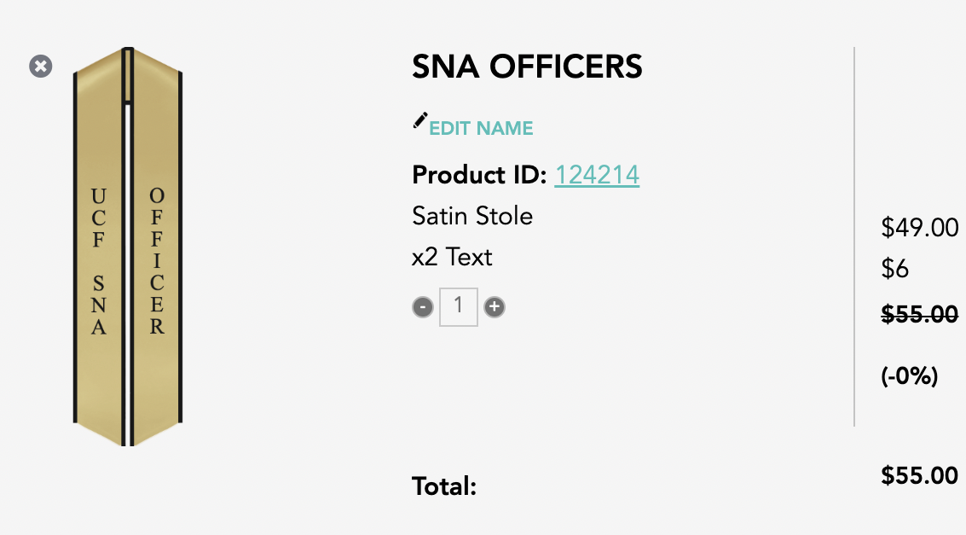  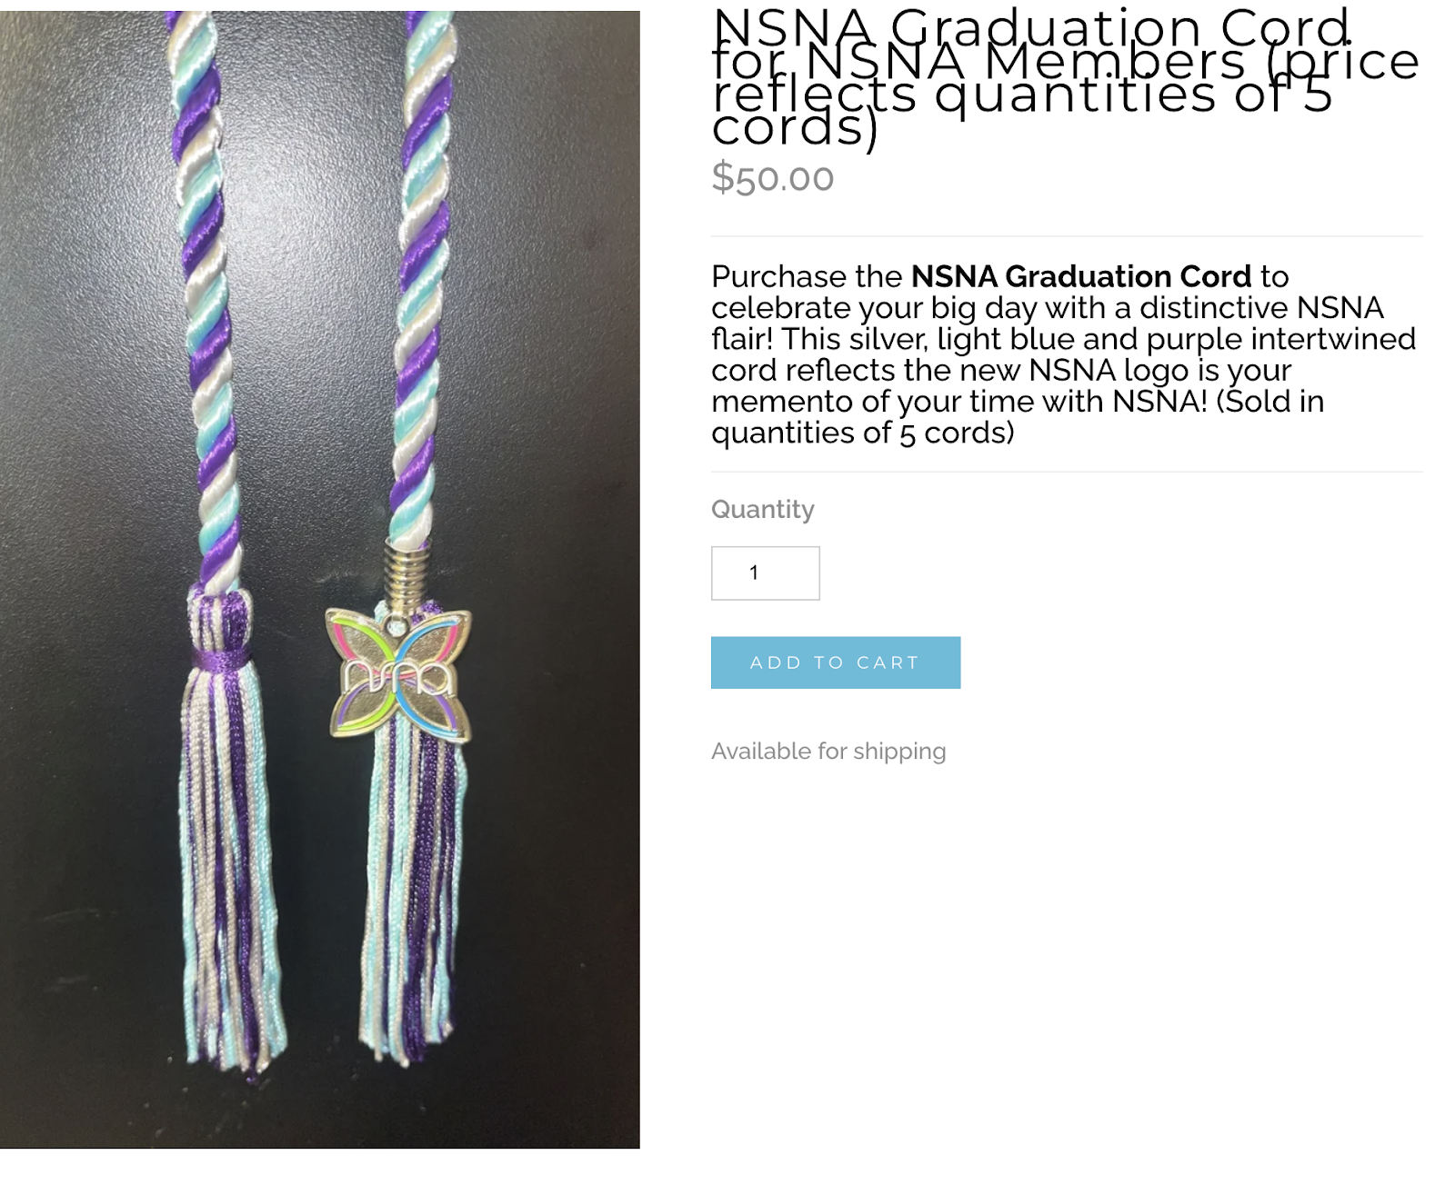  - 5 cords for $50  - Fall Junior Cohort – be sure to promote the upcoming March elections in your classes!  - White Coat Ceremony, Wednesday March 4th  - Location: Student Union  - Time: arrive 12pm  - Volunteers: Ivy, Bri, Willow, Alex, Ally  - Spring Recognition Ceremony (for seniors), May 7th  - Time TBA  - Volunteers (4+ needed): likely will be new elects |  | - VOTE: Allyson makes a motion to allocate $250 to buy 4 more SNA officer soles. Madeline seconds. Motion passes.  - Emergency meeting scheduled for March 11th regarding cord budget. | - No follow-up needed
Vice President:  Briana Dattile | Important updates:  - March: Wed, Mar 11th (5:00-7:30 PM)  - Speaker: SNAP Villanova (CONFIRMED)  - Slides  - Theme: Spring  - Attire:  - Food: Chick-fil-a, fruit plates  - April: Mon, Apr 27th (5:00-7:30 PM)  - Speaker: End of spring alumni panel OR nemours speakers (IN PROGRESS)  - Send point sheets following events  - Candle light ceremony |  | - VOTE: Allyson makes a motion to give attendees to the Zoom session on March 6th, 1 sna point  Madeine seconds. Motion passes. | - No follow-up needed
Legislative Director:  Madeline Sink | Important updates:  - Resolution  - NSNA has accepted it!  - Working with Marianna Gurrola on editing the Resolution  - Convention Planning  - Here is the document that I sent in the GroupMe  - This has the Convention schedule, focus sessions, and Delegate information  - Feel free to add any places, restaurants, or transportation from the airport  - Also, if you guys think of anything to add, just let me know when you guys do add something, that way I am aware of the changes  - Awards are submitted!  - LeadershipUs are completed as well!  - Working on Handoff Report.  - March Elections  - As most of you know, I will not be able to attend the elections. I have a practicum shift on that day; however, this may be a good time for the elects to start practicing their soon-to-be roles. I have already talked to Lucy and Ally about this.  - Application form  - So far, 2 responses  - 1 Historian, 1 Social Media  - The election form has already been created, just need to keep filling in names.  - NSNA Virtual Resolution Hearings are March 23-24, 2026, 6:30-9:00 PM Eastern Time |  | - No action needed | - No follow-up needed
Treasurer:  Aiya Falhi | Important updates:  - Bank Balance: $13,069.70  - Membership Count: 113  https://docs.google.com/document/d/13s6Eg2Jvn7C6SMajA6UBP-crNGk_kuAUe4XWf_GAWuY/edit?tab=t.0  - Aiya is currently waiting to hear back from Mr. Eric Brewington regarding Financial Assistance for Convention |  | - No action needed | - No follow-up needed
Secretary:  Cieara Ambroise | Important updates:  - Upcoming Curriculum Committee Meeting:  - The next Curriculum meeting is on March 24th. If you or anyone you know has anything you’d like me to bring up at the meeting, please refer them to me.  - I will be in attendance!  - The one last week was cancelled.  - Hand-off is prepared  - Vote on February’s meeting minutes. |  | - VOTE: Ciaera makes a motion to approve February’s 2026 board meeting minutes.  Allyson seconds. Motion passes. | - No follow-up needed
Community Health Director:  Marion Jones | Important updates:  - Women’s Health Drive: 23- 27  - Autism Walk- April 4th  - Special Olympics- April 11th  - Nemours Art Volunteer Event: Working out details |  | - No action needed | - No follow-up needed
Fundraising Director:  Chiazoka Ozougwu | Important updates:  - March 1st 2026  - Menchie’s fundraising (12pm-11pm)  - 4100 N Alafaya Trl ste 109  - March 18th 2026  - Merch sales on UCF MAIN Campus  - Possibly bake sale?? |  | - No action needed | - No follow-up needed
Media Director: Ronica Bukasa | Important updates:  - March/April newsletter  - SNA Newsletter Sign Up  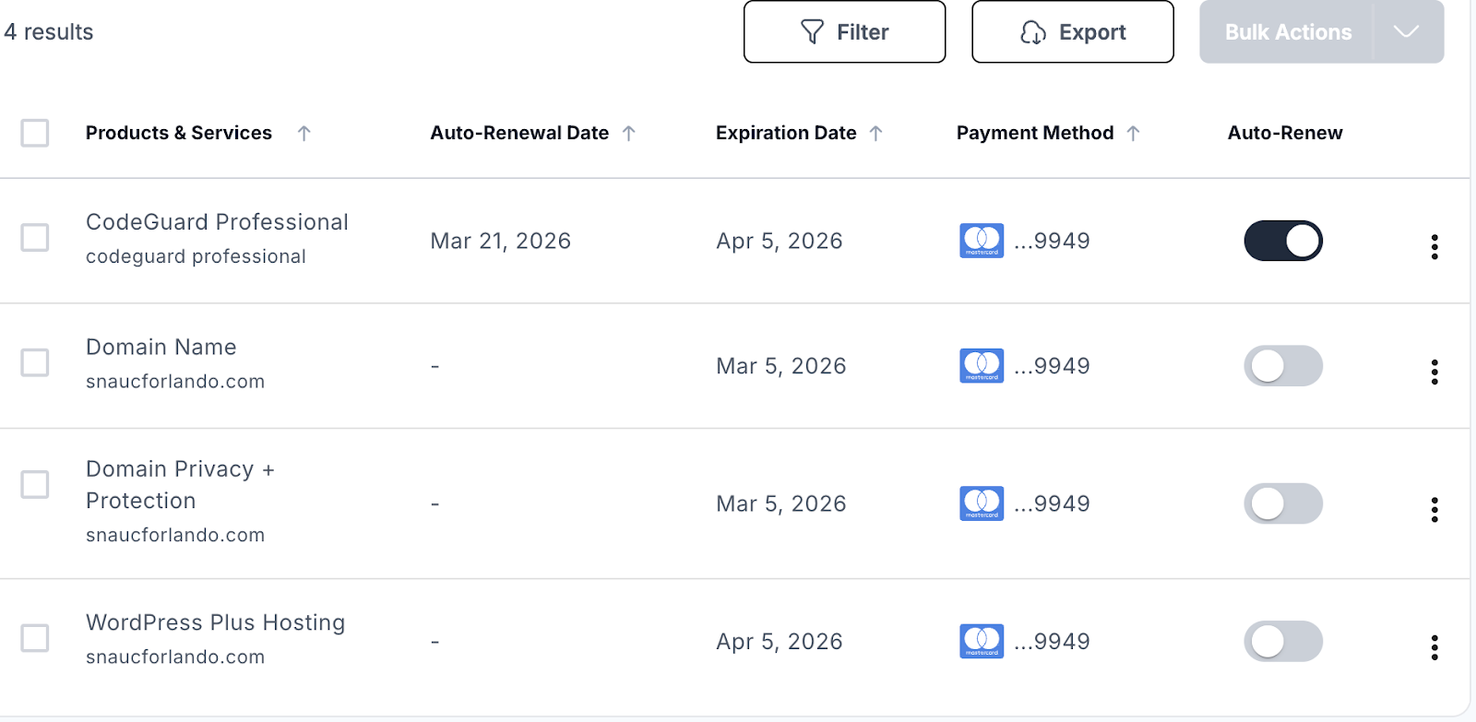 |  | - Ronnie will post an Instagram reel by March 14th.  - Ronnie is working on her handoff  - The SNA website payments will be changed to 1-time payments instead of automatic payments since our SNA card changes every year. | - No follow-up needed
Historian:  Willow Bynum | Important updates:  - Relay for Life  - Saturday, March 7, 2026 at Memory Mall UCF Main Campus  - 12 pm – 9 pm  - Eight total volunteers (including me)  - Tabling idea: quick toss game with mini prizes  - Last historian event: SNA Kickball game  - Tuesday April 14 → Date we’re planning to finalize  - Looking to get Tavistock Green field permission on this date  - Time → Will have to be after class  - The latest class might end that day is 2:50 pm |  | - No action needed | - No follow-up needed
Breakthrough to Nursing Director: Brooke Bynum | Important updates:  - Brooke is currently going through my resources to find new opportunities in the community  - Brooke plans on reaching out to all my mentor-mentees to check in |  | - No action needed | - No follow-up needed
Accelerated Liaison:  Alexandra Duran | Important updates:  - Alexandra received two quotes for the composite photo: $1,350 and $1,600. She is currently waiting on responses from the cohort to see if there’s enough student interest to move forward.  - Alexandra also sent out a form asking if there are any topics students would like me to bring up during the undergraduate curriculum meetings. |  | - No action needed | - No follow-up needed
Merchandise Director: Brooke Sanders | Important updates:  - Brooke is working on making a flyer with alex |  | - We won't be tabling at the convention due to the hassle of pricing. | - No follow-up needed
Advisors:  Kate Dorminy  Brian Peach  Linda Foley | Important updates:  - No agenda |  | - No action needed | - No follow-up needed

