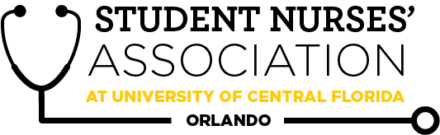 |  | Student Nurses’ Association at UCF Orlando –  February Board Meeting Minutes 2/03/2026  Time Called to Order: 1501 PM  Time Adjourned: 1726 PM  Location: ZOOM  Presiding President: Allyson Crighton  Recorded by: Ciaera Ambroise
Attendees Present: | Allyson Crighton, Hallie Schroeder, Briana Dattile, Aiya Falhi, Ivy Yego, Cieara Ambroise, Madeline Sink, Lucy Bisceglia, Ronica Bukasa, Willow Bynum, Brooke Bynum, Marion Jones, Brooke Sanders, Alexandra Duran, Kate Dorminy, Brian Peach, Linda Foley
Attendees Absent: | Chiazoka Ozougwu
Presenter: | Agenda Item/Discussion: |  | Action: | Follow-up:
President:  Allyson Crighton | Important updates:  - Allyson sent a follow-up email to Addition Finance to plan a discussion for tabling opportunities, but never got a response. Allyson will follow up again.  - We learned that we cannot use room 106A for GBMs due to a lack of audio. We need to confirm that all other GBM bookings are in rooms B or C.  Activities  - I am still awaiting a response from SGA about the funding request. Will need to attend CRT and senate meetings with Aiya and Madeline for the SGA Convention Bill.  - Dr. Loerzel agreed to sign the sponsorship form required for the DSSO status.  - I am awaiting confirmation on DSSO status approval so we can start brainstorming merch ideas with the UCF logo.  - I sent an email to the following three people selected to attend the convention with us: Gabriella Poulson-Valdez, Miguel Salgado Varela, and Samantha Boles. These were the top three point earners among those who filled out the interest form.  - This email included expected costs (subject to change), hotel and flight info, convention schedules, expectations, etc. We will also include them in our chain of NSNA convention communication.  NSNA Awards  - Applications need to be finalized by February 7th, reviewed with the board/advisors, and submitted by February 19th.  Potential SNAP-Villanova GBM Collab  Background Info: Traditionally, our March GBM is held in collaboration with SNAP Villanova (Villanova University’s Student Nurses’ Association of Pennsylvania). Dr. Peach is a Villanova alum and maintains close connections with the university and its SNA faculty advisor, Dr. Weingarten. Members of our board met the Villanova SNA leadership at the NSNA convention in Seattle.  Action: Allyson spoke with their SNA president, Isabella, regarding the possibility of another collaboration this March. Our March GBM date (3/24) conflicts with their clinical schedules.  - SNAP Villanova proposed March 11th as an alternative date.  Discussion: Considerations include the potential need to adjust our current GBM date and/or guest speaker if already confirmed.  Sponsoring Coursen Greene’s SGA Bill  Background Info: Coursen Greene, a UCF SGA Senator, reached out to us in hopes of getting the Student Nurses Association as a sponsor of a proposed bill. This bill concerns recent proposals introduced by the United States Department of Education that exclude Nursing and other Allied Health professions from their definition of professional degrees. Coursen wants to formally denounce these proposals “due to the risk it poses in the U.S. healthcare system as well as making higher education unattainable to many low-income students.” He mentioned that “sponsoring the bill simply means that you support the bill and what it’s saying,” and he would add our RSO to the list of sponsors on the bill.  Action: I responded to his email by saying I would discuss this with the SNA board and reach out once we have made a formal decision about sponsoring this bill. |  | - From now on, SNA needs to confirm our GBM bookings are either in rooms A or B.  - Allyson will see if other rooms are available for use for future SNA GBMs  - Brooke and Allyson will collaborate to see our merch demands and count inventory.  - EVERYONE: Award applications need to be finalized, reviewed, and approved by February 7th.  - Cieara will collaborate with Marion and Halllie regarding applying for awards and which one to apply for. | - Allyson will follow up via email to try to get a response from Addition Financial.  - Allyson will reach back out to Villanova regarding this meeting to let her know we decided to move our GBM to be able to do the meet/collab with them.
Vice President:  Briana Dattile | Important updates:  - February: Tuesday, Feb 24th (5:00-7:30 PM)  - Speaker: (TBD)  - Briana is currently in contact with UCF resources to find a Nemours speaker.  - Theme: Valentine's Day  - Food: Need help with ideas; don't want to go over $100.  - Icebreaker: Would You Rather - Valentine's Day edition  - March: Tues, Mar 24th (5:00-7:30 PM)  - Speaker: Air Force Critical Care - Jake Flores (IN PROGRESS)  - Phone Number: 831-595-9505  - March: Tues, Mar 24th (5:00-7:30 PM)  - March or April: SNAP Villanova in March  - Speaker: End of spring alumni panel (IN PROGRESS) |  | - No action needed | - Briana will continue trying to find a Nemours speaker.
Legislative Director:  Madeline Sink | Important updates:  - February Elections  - Applications sent out  - I have two replies so far  - VP elect - 2  - Fundraising elect - 0  - Madeline is planning on incorporating classroom announcements to try to encourage people running for positions.  - Leadership U Applications - Due Feb. 7th  - If anyone is still interested in completing this, I have it linked.  - NSNA Virtual Resolution Hearings are March 23-24, 2026, 6:30-9:00 PM Eastern Time  - Delegates MUST attend these meetings, which is why we should start thinking about delegates and alternates. |  | - EVERYONE: All those who are interested, please apply for the leadership U application by February 7th.  - Marion volunteered to be an alternate; Lucy, Madeline, and Hallie are delegates. | - No follow-up needed
Treasurer:  Aiya Falhi | Important updates:  - Bank Balance: $12681.75  - Membership Count: 104  - Financial Excellence Award in progress!  - Due Feb 20th; currently in progress  - Still waiting on a response from SGA regarding our submission for Houston  - November Financial Documents: Pending 5 signatures  - I resent December because no one viewed or signed them. Please sign asap!  - January will be out by Friday, February 6th.  - 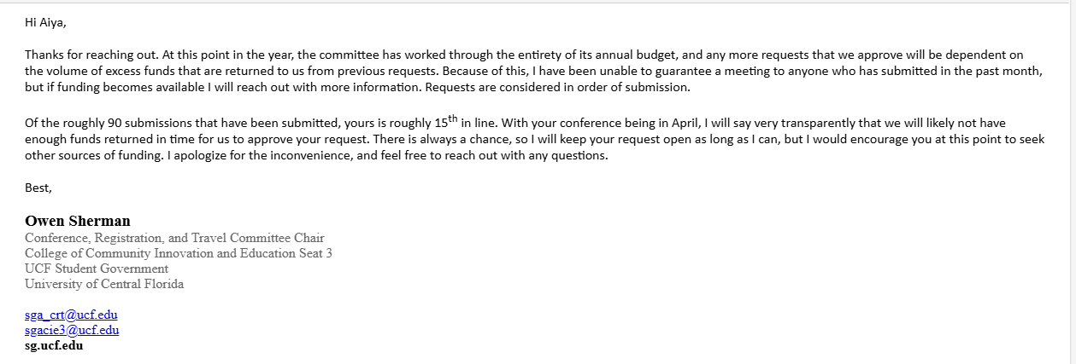  - Fees: $684.14 per room  - Early Bird Registration: $125 per person  - Flight: $162 per person |  | - Aiya will have the financial excellence award revised and submitted by February 11th.  - Aiya will have the January financial documents sent out by Feb 6th.  - Aiya will inquire if we could receive even a fraction of funding for NSNA or reimbursement if we pay on our own. | - No follow-up needed
Secretary:  Cieara Ambroise | Important updates:  - Upcoming Curriculum Committee Meeting:  - The next Curriculum meeting is Feb 24th. If you or anyone you know has anything you’d like me to bring up at the meeting, please refer them to me.  - I will be in attendance!  - Vote on January’s meeting minutes. |  | - VOTE: Ciaera makes a motion to approve January’s 2026 board meeting minutes.  Allyson seconds. Motion passes. | - No follow-up needed
Community Health Director:  Marion Jones | Important updates:  - The Blood Drive has been postponed.  - I was not able to get the documentation in time.  - Nemours Event is on Feb 13th  - Two of my committee members and I will be attending.  - Pregnancy/Women’s Health Drive  - I will start putting that into motion soon.  - Knight’s Pantry  - Likely in March  - Special Olympics  - An event on April 11th, this has been a hit so far, so I will see if one of my committee members is willing to lead  - Autism Walk  - April 4th |  | - Marion will start planning the Pregnancy/Women’s Health Drive  - Marion will see who wants to lead the Special Olympics. | - No follow-up needed
Fundraising Director:  Chiazoka Ozougwu | Important updates:  - Chiazoka plans to organize a Valentine's Day Gram fundraiser and would love support from students in different cohorts to help distribute grams within their own cohorts.  - I will be reaching out soon.  - For the second half of the month, I am planning a restaurant fundraiser, likely at Chipotle or Blaze Pizza |  | - No action needed | - No follow-up needed
Media Director: Ronica Bukasa | Important updates:  - Ronica is completing February’s Lifeline Newsletter |  | - Ronica will send out the lifeline newsletter by tonight, Feb 3rd, and get it approved by advisors. | - No follow-up needed
Historian:  Willow Bynum | Important updates:  - The next event is Relay for Life on March 7th, 2026.  - Location: Memory Mall on UCF Main Campus.  - Time is still TBD.  - Willow is working on getting together details and sign-up information to push out to the general body members on socials.  - Willow is trying to work out the possible costs for this event.  - I’m anticipating the SNA Kickball game to happen either late March or early April. |  | - No action needed | - Willow will gather details and sign-up information to push out to the general body members on socials.
Breakthrough to Nursing Director: Brooke Bynum | Important updates:  - Brooke is currently working on making sure Mentor/Mentees are communicating  - The next event: Career fair  - Hagerty High School  - February 26th, 9 am-11 am |  | - No action needed | - No follow-up needed
Accelerated Liaison:  Alexandra Duran | Important updates:  - Alexandra is coordinating a composite photo for the Accel cohort  - They asked for my help with this.  - Already have a few quotes from different companies |  | - No action needed | - No follow-up needed
Clubhouse Director: Brooke Sanders | Important updates:  - Brooke is recounting inventory |  | - Brooke will have merch inventory completed by February 13th. | - No follow-up needed
Advisors:  Kate Dorminy  Brian Peach  Linda Foley | Important updates:  - No agenda |  | - No action needed | - No follow-up needed

