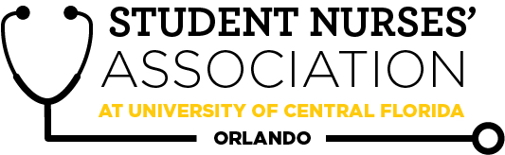 |  |  |  | Student Nurses’ Association at UCF Orlando – November Board Meeting 11/11/20  Time Called to Order: 1701  Time Adjourned: 1858  Location: Zoom  Presiding President: Samantha Cooney  Recorded by: Amanda Shover
Attendees Present: |  | Samantha Cooney, Chloe Frye, Sadie Richards, Hope Wegge, Amanda Shover, Josee Etienne, Amber Keller, Audrey Been, Natalie Klosinski, Delaney Dietz, Megan Donnelly, Andrea Garcia, Joyce DeGennaro, Kate Dorminy, Brian Peach, Lauren Fuller, Leah Utt
Attendees Absent: |  | Brian Peach (left early), Joyce DeGennaro
Presenter: | Agenda Item/ Discussion |  | Action: |  | Follow-up:
Samantha Cooney- President | - General Meeting Dates:  - November 18th @ 1700  - January 27th @ 1700  - Board Meeting Dates:  - December: TBD  - Christmas party  - January 12th?  - 2021 NSNA Convention  - April 7-11  - Takeaways/learning lessons from convention  - Resolutions; presenting be prepared on your resolution, majority of the state board from one university  - Encourage nursing students to run next year- plan ahead!  - Goal of going to convention with at least one person we will promote  - Contact with region 3 director  - Amanda Stack (previous Community Health Director) still has the shirts for Knight-Thon that we can reimburse/purchase from her for future events  - 15-17 plain grey shirts and red, white, and yellow vinyl that’s compatible with a Cricut.  - They’re blank, they were going to be sent to someone to be made so it’s the materials since the event got canceled.  - All together the total was $132.35, and she is asking for reimbursement  - Sam is working on signing up everyone for KnightConnect |  | Natalie Klosinski will be speaking to APNS; providing informational session on SNA and how they (UCF nursing students) can be involved at the state and national level.  Ensure the next elects (future junior class) have their role in September to be able to attend convention and learn directly from their position.  Poll in group-chat to discuss dates for Christmas party. |  | - Christmas party date  - Amanda Shover will get in contact with region III director.  - Get back to Amanda Stack at a later date (no official vote or purchase on shirts).
Sadie Richards- Vice President | - November general meeting  - Guest speaker: Kathryn Coats, MSN, PMHNP-BC  - Forensic Nursing  - She will be speaking virtually  - No food  - Zoom  - Student lead IPE event coming up in Spring  - Will keep you all updated on the plan for the event.  - Possible partnership for this month’s general meeting  - Ice Breaker Activities  - Breakout groups on Zoom with one or a few board members facilitating each group to create a more personal experience.  - Would you rather? Within reach?  - Kahoot game for a more interactive experience |  | We will start off the meeting with breakout rooms having one board member in each session (be sure to change Zoom name to student name and position on board). |  | Sadie is going to get in touch with Dr. Peach regarding the speaker to confirm details for the November general meeting.  Sadie will provide update before the next general meeting on our possible partnership.
Chloe Frye- Treasurer | Current Balance: $17,140.68  Current Membership Count: 140  Sending out membership form again in December-January.  Payment for Sweatshirts?  - Payment to American Business Solutions:  - $507.58 for preorder  - $389.79 for proposed restock  - $897.37 total payment
Leah Utt- Clubhouse Director | Sweatshirts payments in!  - Total sold: 31 sweatshirts  - Total collected payment: $930  - Net total with fees: $892.80  - Total cost with 6.5% tax: $507.58  - Projected profit: $385.22  Proposed restock  - Current inventory: 1 M Gray, 1 XS Black  - Proposed restock: 4 of each size for both colors  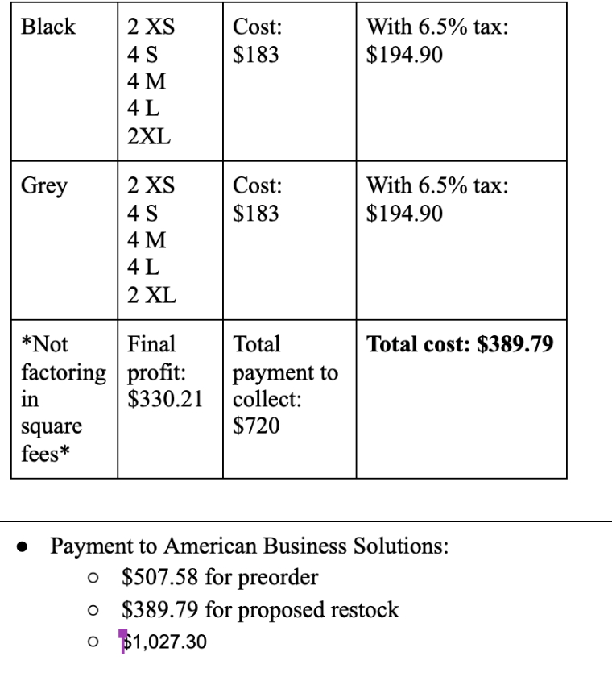 |  | Will add XS and XL sizing (2) to be more inclusive.  We will be selling at national convention, but we would need to pay to bring an extra bag of merchandise.  Can we do a card payment with American Business Solutions?  - History of not cashing checks immediately  - Card would provide a more instant payment  **VOTE**  Leah makes a motion to move forward with the pre-order (31)and proposed stock (2 XS, 4S, 4M, 4L, 2XL) of the “Knight Nurse” sweatshirts for a total payment of $1,027.30 to American Business Solutions.  Josee seconds.  Motion passes.
Megan Donnelly- Accelerated Liaison | - Curriculum Committee Meeting 11/10  - Plan to promote Relay for Life & Knight-thon  - Wonderful feedback on Mr. Marcus Engel!  - Let me know if anyone needs assistance with any of your projects :)
Josee Etienne-  Legislative Director | - WELCOME NEW OFFICERS!!  - I am so excited to get to know you guys as fellow board members and as individuals.  - Financial planning for National Convention (April 7-11)  - I am so excited to have this one in person. Since the dates have been confirmed, I will start the financial process next week.  - Have a great Thanksgiving
Hope Wegge- Fundraising Chair | Last month’s fundraisers  - Spooky Basket  - Huge response!!  - $273 profit  - Special Mask Order from Christina Gonzalez (50 count)  - $191 profit  - October total: $464  Chick-fil-a Fundraiser (University location)  - Partial proceeds (15%)  - Guests can let the order takers know they are here to support SNA  - Drive-thru only → social distancing :)  - When  - Tuesday, November 17th or Wednesday, November 18th  - 5-7pm or 6-8pm  - Cost: $0  - No payment in advance or minimal $ for us to get proceeds!  - Advertise with flyer by tomorrow (11/11)  - Email, social media (Amber), group me  - ASAP  - Should students receive SNA point incentive for going? YES!  - Fundraiser for December? NO. |  | **VOTE**  Hope makes a motion to hold Chick-fil-a fundraiser on Tuesday November 17 from 6-8pm.  Samantha seconds.  Motion passes.  Hope will post on the flyer the incentive of one SNA point, and she will facilitate the points.  Advertise to APNS (send flyer to president), nursing at Nike, and alumni (send flyer to Christina Gonzalez) as well.
Natalie Klosinski- Breakthrough to Nursing  Director | - Planning a philanthropic event with APNS → second harvest food bank  - Mrs. Briet will let us know the time slots  - Also planning on other events with them in the near future  - After winter break, APNS president would love to have nursing students come to Zoom in for Q&A  - Waiting for responses from a few high schools about doing Q+A panels, etc., or if they have any events  - Organizing event with Aloma Elementary → Children’s Mental Health awareness month  - Virtual Tour of CON → any suggestions?  - Connect with SIM team  - Organizing an event with Leah to speak to Freedom’s anatomy class → waiting on details |  | If anyone knows Daytona or Cocoa Beach nursing students, reach out to Natalie!
Amber Keller- Media Director | Next newsletter submission deadline is November 22  Board members submitting:  - Josee  - Amanda  - Audrey  - Sadie  Send any student and faculty spotlight nominations!  FACEBOOK  We have the ability to create Facebook accounts with SNA email to stay more professional.  - Can set up using: personal name (position), SNA as profile photo, and SNA role description in bio.  - With this account, we can join and post in cohort groups (with a quick introduction of role).  - I recommend passing down the account along with the SNA position like with the email accounts.  - I recommend accounts for the following positions at this time: media director, fundraising director, community health, and vice president. |  | **VOTE**  Amber makes a motion for the media director, community health director, fundraising director, and vice president to make Facebook accounts with SNA email account to post in Facebook groups  Samantha seconds.  Motion passes.  Amber will send, via GroupMe, the designated profile picture and cover photo for Facebook accounts.
Audrey Been- Historian | - Last Month:  - Composite day went well  - Next Alumni Chapter meeting  - 11/17 (at 6:00pm)  - Nurse Blake will be there- take pictures!!  - Relay for Life  - $320 raised
Delaney Dietz- Community Health Director | - Saturday, November 14th: AHA walk  - SNA members will meet to walk around UCF campus  - Link to sign up in GroupMe  - Hygiene kit collection  - Drive-thru collection next week  - Make hygiene kits on November 23rd  - Straight Street on November 24th  - In conjunction with Orlando Against Corona?  - Reaching out to this group from UCF and they make hygiene kits to donate to homeless  - Future opportunities :)  - Hopefully RMH will reopen to volunteers so we can make at least one meal for the families (if not will probably do one more collection)  - Knight-Thon (April)  - Straight Street collaboration with UCF Med students  - Health screenings for patrons of Straight Street (BP checks and general education)  - Would be looking to discuss further next semester- make sure they are complying with UCF guidelines
Amanda Shover- Secretary | - CC meeting today, 11/10 at 1:30  - Kahoot for the next General Meeting’s NCLEX review questions (I can take charge on that!)  - Are we interested in doing another raffle for members who stay the full duration of the meeting? |  | Kahoot for NCLEX-style questions will take place at right before the speaker presents and winner will be awarded $5 e-gift card.
Advisors:
Joyce DeGennaro

Kate Dorminy

Brian Peach

