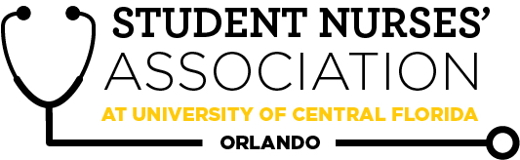 |  | Student Nurses’ Association at UCF Orlando – November  Board Meeting MINUTES 11/02/2021  Time Called to Order: 17:00  Time Adjourned: 17:50  Location: Zoom  Presiding President: Erin Tonkin  Recorded by: Caroline Porter
Attendees Present: | Erin Tonkin, Vanessa Iturri, Monique Csenteri, Caroline Porter, Lauren Fuller, Alexandria Moran, Emily Jones, Sarah Stukey, Cynthia Fonseca, Samantha Maiolo, Peyton Hawks, Megan Fleming, Alexis Wade, Annaliece Balensiefen, Kate Dorminy, Brian Peach
Attendees Absent: | Kaitlyn Yu
Presenter: | Agenda Item/Discussion: |  | Action: | Follow-up:
President:  Erin Tonkin | - Future Board Meetings:  - Tuesday, November 2nd  - December meeting typically a "Christmas party" so we can discuss what date works best?  - Possibly Dec 8th- that is the last day of finals for everyone  - Waiting to see if UCF has any changes regarding food and indoor meeting  - Future General Meetings:  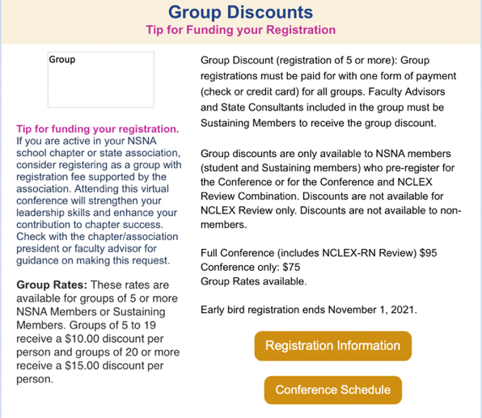  - Wednesday, November 17th (this is not the last Wednesday because of Thanksgiving)  - I hope everyone had a great time at convention!!  - Thoughts on NSNA mid-year convention?  - It is next weekend, most of us have a test the following week  - Not something we typically go to  - November 9th- APNS invited us to speak at their meeting at 6:00pm, can anyone attend? Let Erin know if you can attend  - Peyton and Erin are going  - Dr. Peach and Mrs. Dorminy would like to speak to us regarding a potential collaboration with UF's chapter!  - UF’s chapter would like to work with us and potentially hold a meeting together and get ideas to take back to their chapter  - Collaborate on Newsletter, do a fundraiser competition, etc.  - Elect badges are in! Will receive them at the next general meeting  - Diamond Chapter goes from October to October, so now Kaitlyn is on charge of Diamond Chapter for next year so send any pictures you have to Kaitlyn or Erin for it |  |  | - Board meeting time for next semester since class schedules change
Vice President:  Vanessa Iturri | - November 17th SNA General Meeting  - Guest speakers: (possibly)  - UCF OB clinical instructors  - Erica Glass  - Brittany Breau  - Food:  - Publix Subs  - SNA Points  - Up to date  - Going to follow up with RSO about eating indoors  - Katrina would like to interview with a couple of nursing students of about the importance of critical care so that she can submit her article  - Erin and Emily said they would be able to
Treasurer:  Monique Csenteri | - Current Balance: $19,814.27  - Current Membership Count: 125  - Tax update:  - We received word back from the IRS, and the previous application was missing a signature. I have mailed in the form with the signature and I’m waiting to hear back about our nonprofit status.  - Friendly reminders:  - All board members must sign the last page of the bank statement, financial report, and Venmo report. They are available now! Please have these signed by 11/03/2021 @ 2359.  - October Financial Report:  - https://docs.google.com/spreadsheets/d/1_ekHmn2qSdklutBLLlHhEN-Ea6OSXY46/edit?usp=sharing&ouid=116804384623224111037&rtpof=true&sd=true  - October Bank Statement:  - https://docs.google.com/document/d/1ec7_V4sloJUzS8y2wiD6irD5U22gC2-K/edit?usp=sharing&ouid=116804384623224111037&rtpof=true&sd=true  - October Venmo Report:  - https://docs.google.com/spreadsheets/d/1kfLX7a_Nw2ZTCx2Yv3aC_SWW85Bx_fL3ME0FHkiocfc/edit?usp=sharing  - Receipts:  - https://drive.google.com/drive/folders/1LdKgXlzfgFyL-vfmqfTqej1cu4Ue4OfZ?usp=sharing  - 2 officers at the cash box at all times  - All officers can accept membership forms  - Must provide a receipt to get reimbursed  - Encourage Membership all you can!  - Bank Card must be signed in and out in order to use it  - EVERY purchase made with the SNA card REQUIRES a receipt to be sent to the treasurer within 48 hours of purchases |  |  | - IRS Nonprofit status
Secretary:  Caroline Porter | - Approve October Board Minutes  - Kahoot game  - Next CC meeting 11/9  - Survey had multiple responses  - Scratch paper for exams  - Having exams on the same week  - Limit use of VSIM and SH  - More study guides/materials outlined in each class  - Online option for class  - Better communication w/ students as far as scheduling  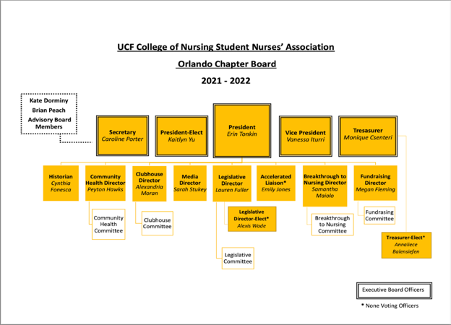  - Guest speaker gift card  - Org Chart |  | **VOTE**  Caroline makes a motion to approve the October 2021 Board Meeting minutes.  Vanessa seconds.  Motion passes unanimously.
Legislative Director:  Lauren Fuller | - Thank you all for your flexibility with the State Convention, still waiting to hear back on the voting link.  - Potential Bylaw Amendment:  - Amend Section X Article 1 to read “The Board, at its discretion, shall establish committees deemed necessary to carry on the work of the association and determine functions, terms, and membership of the committees. A quorum for committee meetings shall be a majority of the members. The appointment of SNA members to the committees shall be determined by the board member responsible for the committee.”  - After discussion among the board Lauren is going to change the wording to state along the lines of it being determined at the discretion of the board as a whole |  |  | - Final wording of bylaw amendment
Clubhouse Director:  Alexandria Moran | - Helped table on 11/1 during the Gift of Life swab drive  - Helped table during the Senior Composites  - Helped coordinate the AHA shirt making event and helping with the collection of shirt-making supplies  - Started to inquire with another shirt making company since the current company is no longer replying what so ever
Accelerated Liaison:  Emily Jones | - Will be continuing to receive feedback and reviewing google forms completed up until the next Curriculum Committee Meeting and planning on incorporating that with the agenda  - Continuing encouragement for those involved in the Knight Nurse Mentorship program (:  - As always, let me know if I can help in any way!  - I know Halloween just passed, but does SNA/CON do a holiday party in late November/early December? Would love to help plan if that’s a thing! (:
Media Director: Sarah Stukey | - Lifeline Newsletter  - Next submission date will be November 19th!  - Right now, the only officer signed up to submit an article is Cynthia! I would like to have 1 or 2 more people sign up!  - Please continue to submit nominations for student and faculty spotlight!  - Social Media  - Introduction clips for all of the officers (for highlight reel)  - 10-15 second clip  - Name, Position, 3 duties you hold  - Please text it to me or Group me by Nov 10th
Historian:  Cynthia Fonseca | - Composites were a success! Thank you to everyone who participated and special shout out to Alex and Mrs. Dorminy for helping me set up tabling!  - I have heard lots of positive feedback about the Knight Nurse Mentorship program and will continue to remind everyone monthly at the meetings to touch base with their mentors  - I am looking forward to the next Alumni chapter meeting in two weeks!
Breakthrough to Nursing Director:  Samantha Maiolo | - Upcoming Events:  - Oviedo HS Medical Club - Tuesday, November 16th @ 2pm  - TBD Lake Nona Middle School STEAM Night  - Past Event:  - University HS Anatomy Classes
Community Health Director:  Peyton Hawks | - Gift of Life Bone Marrow Drive yesterday went great! We had about 35 students get swabbed and sold a few SNA T-Shirts.  - Heart Walk will be on Saturday, November 13th.  - Sign-ups are now closed  - I’ll be using my monthly budget to buy shirts and decorating supplies this week  - T-shirt decoration day is November 9th from 11-3pm in room 650A  - I have not heard back from anyone I emailed about EDC so it looks like we most likely will not be volunteering :(  - Good news is CFDMT is still involved in the Disney marathons that we can volunteer at in January
Fundraising Chair:  Megan Fleming | - October Fundraiser:  - The Spooky Basket raffle fundraiser made: $218  - November Fundraiser:  - I’m putting together a partial proceeds with Chick-fil-a but I’m still waiting to hear back from them on a date!
Advisors:  Kate Dorminy  Brian Peach | - National Convention will be held in Salt Lake City, Utah at the Salt Palace Convention Center. It is currently set to be in person.

