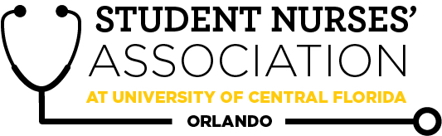 |  |  |  | Student Nurses’ Association at UCF Orlando – MARCH Board Meeting MINUTES 6/24/20  Time Called to Order: 1701  Time Adjourned: 1903  Location: Zoom  Presiding President: Samantha Cooney  Recorded by: Amanda Shover
Attendees Present: |  | Samantha Cooney, Chloe Frye, Sadie Richards, Hope Wegge, Amanda Shover, Josee Etienne, Amber Keller, Audrey Been, Natalie Klosinski, Delaney Dietz, Megan Donnelly, Leah Utt, Kate Dorminy, Brian Peach, Monique Csenteri, Erin Tonkin, Lauren Fuller, Samantha Maiolo, Caroline Porter, Cynthia Fonseca, Vanessa Iturri, Peyton Hawks, Megan Fleming, Sarah Stukey
Attendees Absent:
Presenter: | Agenda Item/ Discussion |  | Action: |  | Follow-up:
Samantha Cooney- President | ~ACTIVITY~  - Welcome new board members!  - Contacted Villanova’s Student Nurses’ Association of Pennsylvania  - Board is willing to attend our March meeting; waiting on our official meeting details  - Roles/responsibilities hand-off sheet  - If created for future students in your role, please email this to Mrs. Dorminy!!!!  - General Meetings  - March 31st  - April 21st  - Board Meetings  - April 5th (first night of convention- discuss our plan for convention)  - Convention on April 5 will be from 1200-1830  - Team building for the new board- Erin will take over on this.  - Custom adventure trips/in-person challenge course programs  - Previous years did field day, yoga, etc.  - Faculty/staff vs. student kickball game  - Set date for April? This event would need to be before spring break due to UCF closing on-campus events  - DATE: March 23, 2021 at 1700  - A great fundraising opportunity  - Hope, Amanda, Audrey, and Sam will take lead on this project  - David Frederic is part of UCF alumni committee wants to come speak to seniors and accelerated students about DNP/FNP zoom conference call with UCF alumni  - Sam will offer the date of March 16 at 1230 via email  - Sam will promote and send out Zoom link for anyone to join |  | **VOTE**  Samantha motions to charge faculty/staff and non-SNA members $5 for the kickball event.  Chloe seconds.  Motion passes. |  | Need to book Lake Claire for the faculty/staff kickball tournament  by TOMORROW at the latest.  Backup  option would be to look  into intramural fields if Lake Claire does not work.
Sadie Richards- Vice President | - March 31st General Meeting  - Speakers:  - Darleen A. Williams, Clinical Nurse Specialist for Emergency Services, ORMC and David Townsend, Clinical Sepsis Coordinator, ORMC  - Topic:  - ‘Sepsis S.U.C.K.S’  - MOC AACN: about 10-minute presentation  - Mode of meeting: IN PERSON AND ON ZOOM- Blendflex  - Food  - None  - Will follow-up with Villanova with meeting details  - Interprofessional Event (IPE Event)  - Saturday, April 3rd, 10am-2pm  - Working with Ms. Dever on a patient case from the CON.  - Critical Care Case  - Villanova  - Allow the president to talk about their association  - Allow board members to discuss their roles  - Connect with them prior to meeting to go over how this will run |  | **VOTE**  Sadie makes a motion to vote for the meeting in person/blendflex at the College of Nursing.  Samantha seconds.  Motion passes.
Chloe Frye- Treasurer | Current Balance: $17,210.53  Current Membership Count: 142 (51 seniors, 41 accels, 50 juniors)  - Cords- discussed in Leah’s section  - Still waiting on funding for convention! We will then be able to register everyone.  Friendly reminders:  - All board members must sign the last page of the bank statement, financial report, and Venmo report. They are available now! Please have these signed by 3/7/21 @ 2359. Please please please have this signed promptly. EVERYONE attending the meeting tonight, PLEASE SIGN.  - All officers can accept membership forms  - Must provide a receipt to get reimbursed!!!  - Encourage Membership all you can!  - Bank Card must be signed in and out in order to use it  - EVERY purchase made with the SNA card REQUIRES a receipt to be sent to the treasurer within 48 hours of purchase AND should always be approved prior to purchase  Tax Update: waiting on correspondence back from our representative who is able to offer the services we need  Amanda Stack t-shirt update: do we pay her back? Do we find something to do with the t-shirts? We would have to pay $132 for the t-shirts: 5S, 9M, 2L, and 1 XL = 17 t-shirts as well as white, pineapple, burgundy Cricut paper.  - Options: could be a new shirt for the newly elected board members. Cynthia suggested her mom as an option to help decorate shirts.  - At this point in time, the board has determined we have NO use for the t-shirts and will not be reimbursing her. Delainey will pass on Amanda Stack’s contact information to be Monique for any future contact needed.  - Poll Results: 6S, 2M, 2L which would work if the new board decides to purchase the shirts at a later date. 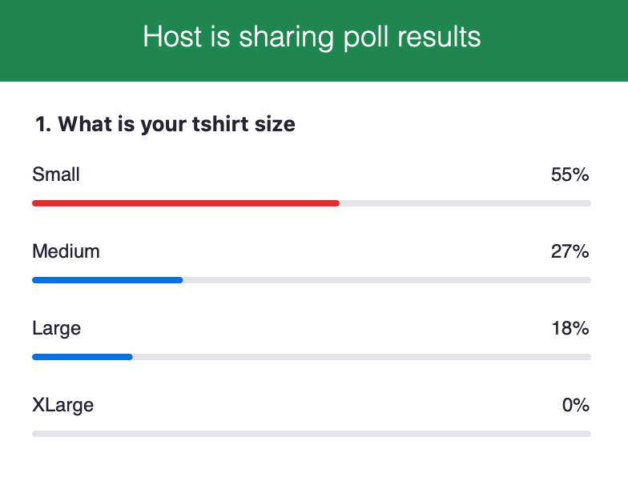  ***FOR FUTURE, hold an emergency meeting or mention any purchases at the board meetings to avoid this problem*** |  | Amanda Stack T-shirt Update:  **VOTE**  Chloe makes a motion to |  | Chloe will keep us updated regarding the tax situation.
Leah Utt- Clubhouse Director | - Cords  - Current inventory - 43 (enough for accels this summer)  - Restock proposed for seniors graduating this semester  - Website is finished!!!!  - Test run with cords?  10 seniors on the board  The cords come in packs of 5… 3 can go to the top SNA point earners & 10 for the senior board members with us purchasing 3 packs or cords.  - ucfsnaorlando.square.site  - Signed up for student activity tile  - Haven’t received any info |  | **VOTE**  Leah makes a motion to buy 3 packs (5 each) for a total of 15 cords for a price that comes out to $165.07  Hope seconds.  Motion passes.
Megan Donnelly- Accelerated Liaison | - Curriculum Committee Meeting TBD March  - Accel Mentorship Program in March / April  - Aiming to have matches done two weeks prior to the semester starting on May 17th  - $415 donated on behalf of Accelerated cohort to CON Memorial Scholarship Fund on behalf of Mrs. D
Josee Etienne-  Legislative Director | Welcome to our new board members!!  National Convention  - Funding:  - Our Senator Mr. James Evans has been keeping me updated with our fiscal bill (bill number 52-90). It is currently processed by Student Development and Enrollment Services (SDES).  - Delegates  - Just a reminder that the delegates will also need to be available on April 1st and 2nd for NSNA national convention.  - Time: 4:00-7:00PM  - Delegates will be selected at random  - Resolutions  - I did receive the email that it has passed the first review by NSNA.  - We also got assigned a designated person for questions and concerns. Cameron Huston chuston@sentara.edu.  - National Positions  - I want to also encourage our veteran and our tyro board members to consider running for state and national positions. There are still open slots for state. I recommend you check the website to see what’s available.  Goodbyes  - I would love for all of us to hang out before the seniors leave. Any ideas?
Hope Wegge- Fundraising Chair | Valentine Basket → $324 profit  March Fundraiser will be the student/faculty kickball tournament at Lake Claire.  Special Knight Nurse Shirts (APRIL Fundraiser)  ) 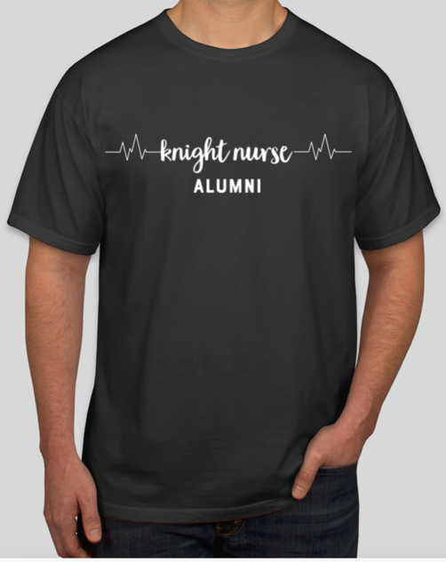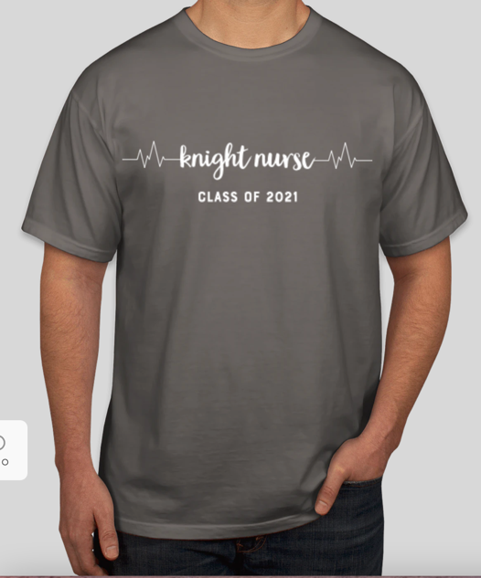  - Supplier: Custom Ink  - Who: class of 2021 grads (traditional/accel) + alumni options  Price: $20 or $25 each  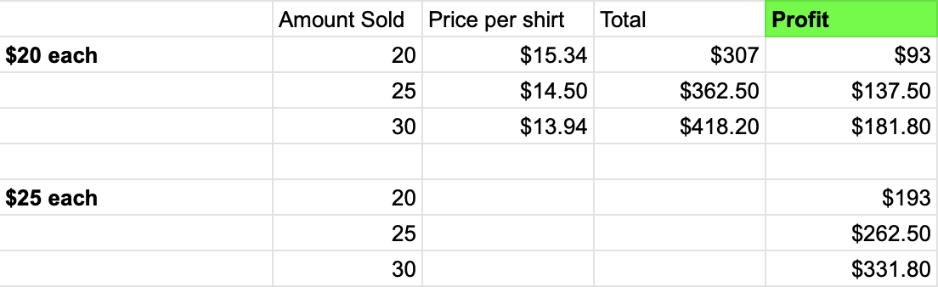  - Pre-order through Google Forms  - Advertised through social media, GroupMe, email in the middle-end of March  - Ships in ~2 weeks → pick-up similar to face mask event  - If we do a senior drive-thru, we can order extra shirts to be able to sell there as well!  - ~VOTE~  - Contacted Blaze. We should be receiving the check anytime. Profit was $89 |  | **VOTE**  Hope makes a motion to sell these knight nurse shirts at $20 each as pre-orders through Google Form.  Chloe seconds.  Motion passes.  When all orders and done and in, we will hold an emergency meeting to order extra shirts. |  | When all orders and done and in, we will hold an emergency meeting to order extra shirts.
Natalie Klosinski- Breakthrough to Nursing  Director | - Virtual CON Tour  - Pre-recorded, show Sim Lab, etc  - Watch event with different schools/pre nursing students, followed by a Q&A  - Skills Demonstration/panel with Oviedo HS Medical Club  - Can this be held at CON?  - Vital signs demo, maybe Sim lab?
Amber Keller- Media Director | Last Newsletter Submission Deadline of the semester:  April 18th  - All 2020-21 Board Members submit for April edition  - When you include a reference, make sure you have a correlating citation.  - Include pictures :)  - Let me know any spotlight recommendations  Renewal of Bluehost this month.
Audrey Been- Historian | - Relay for Life date still TBA  - Make graduation video google drive or dropbox  - Lake Claire Day  - Reserve day at Lake Claire  - Food/catering? Vouchers or coupons from local businesses?  - SNA cords sold  - Print fliers and hang around CON
Delaney Dietz- Community Health Director | - Knight Thon - March 20th  - Raised almost $1800!  - RMH Collection  - Morning of March 31st  - Straight Street  - First week of April
Amanda Shover- Secretary | WELCOME to our new board members! So excited to have you all join us :)  → I will take care of the thank you cards and Starbucks cards for the guest speakers at the next general meeting  → Kahoot for next meeting  → CC 3/9
Advisors:  Kate Dorminy  Brian Peach | - Dr. Peach spoke with Sigma president and they are NOT able to purchase the t-shirts that Amanda Stack (prior board member from last year) had purchased last year.

