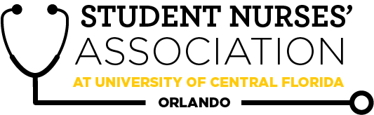 |  | Student Nurses’ Association at UCF Orlando – JANUARY  Board Meeting MINUTES 01/12/2022  Time Called to Order: 17:34  Time Adjourned: 18:54  Location: Zoom  Presiding President: Erin Tonkin  Recorded by: Caroline Porter
Attendees Present: | Erin Tonkin, Vanessa Iturri, Monique Csenteri, Caroline Porter, Lauren Fuller, Alexandria Moran, Emily Jones, Sarah Stukey, Cynthia Fonseca, Samantha Maiolo, Peyton Hawks, Megan Fleming, Annaliece Balensiefen, Alexis Wade, Kaitlyn Yu, Kate Dorminy, Brian Peach
Attendees Absent:
Presenter: | Agenda Item/Discussion: |  | Action: | Follow-up:
President:  Erin Tonkin | - Board Meetings @ 4pm:  Wed. February 2nd  Wed. March 2nd  Wed. April 6th (first night of state convention)  Wed. May 4th  - General Meetings:  Wed. January 26th  Wed. February 23rd (fun fact: this is nursing student day – we should celebrate!)  Wed. March 30th  Wed. April 20th  Wed. May 25th  - We should start reaching out to SGA for funding regarding National Convention. Erin, Vanessa, Caroline, and Sam are the board members who completed the class for Knight Connect purposes, is this the same as RSO financial training?  - Erin and Caroline will complete the RSO financial training because we only need two to fill it out.  - I have been in contact with the President of UF’s SNA chapter. They are not very established and she has expressed interest in her board attending one of our board meetings to observe how we run our organization. I then proposed maybe breaking into quick breakout rooms with corresponding board members to exchange contact info/ tips and ideas. Are you guys okay with me inviting them to our next board meeting on Wed. February 2nd?  - Erin has a meeting with UF SNA President next week and they will figure out the details about their board members joining our next board meeting and one of our general meetings.  - Everyone was in agreeance about having them join the next board meeting along with our general meeting so they could get ideas on how to run their meetings.  - Lauren is going to check the bylaws, we should be able to consider this a joint meeting so they do not have to pay to attend the general meeting.  - Peer Tutoring Program  - Seniors/Accels to Juniors  - Lots of logistics to figure out  - Mrs. Dorminy – talked with Dr. Allred about this? If so, what did she say?  - Mrs. Dorminy does not recall an update, but will follow up with Dr. Allred.  - Start Fall 2022? Or sooner?  - Probably best to wait till Fall 2022 to start this.  - Medical Mission Trip  - Previously summer trip to Peru, counted as class credit  - Mrs. Dorminy – Inquired with Dr. Diaz? If so, what did she say?  - Dr. Diaz would be the best person to talk to, since she is the one who runs it.  - Most feasible through CON? Or Well Child International?  - May be best to have an organization to plan this trip for us because it may be difficult for us to do this ourselves along with school.  - Summer 2022? Or Summer 2023? Only rising seniors or other cohorts?  - Would be at the discretion of Kaitlyn and her future board if this is something SNA wants to do and how it ties into SNA. Would be best to talk to some of these organizations to see what it would take to plan a trip like this.  - Update- FNSA held a vote for state positions. We have not had any announcement of results yet. |  |  | - Dr. Allred’s reply to Peer Tutoring Program.
Vice President:  Vanessa Iturri | - January 26th General Meeting  - Guest Speaker: Jason A. Duprat MBA, MSA, BSN, CRNA  - Food:  - Publix Subs  - Any other ideas for a budget under $120?  - The Dean has asked that we not serve food at the January and February General Meetings  - SNA Points are up to date  - Zoom component?  - Yes, there will be a zoom component since UF SNA will be attending this meeting.  - February 23rd SNA General Meeting  - Tom Weichart  - Former White House nurse Tom Weichart. He will speak about his roles as a nurse for the President of the United States. He may also speak about current policies and the political side of nursing and why it is important to be informed about healthcare legislation!  - HM1(FMF) Kuhn, Steven, contacted me about presenting to our organization in hopes of talking about active duty, reserve, and student programs available. Do you think our Cohort would be interested in this? Or should I suggest the career fair on February 8th?  - Would be best to suggest the Career Fair since it is more a recruitment type of event.  - Is SNA willing to pay for Liza and Savannah’s ticket to the convention?  - Since they will be representing UCF at a National level they should be highly considered to be covered in full for convention.  - If FNSA pays for state board members to attend convention, funding that would have originally been used for those chapter board members could be used for their coverage to nationals as well.
Treasurer:  Monique Csenteri | Current Balance: $18,997.83  Current Membership Count: 129  - Tax update:  - The IRS said they received our application and we should be hearing back within 180 days with a determination letter.  - I need a second opinion on the due date for our yearly taxes. According to the IRS website, the due date for the 990-N form is due “every year by the 15th day of the 5th month after the close of your tax year.” According to our bylaws our “fiscal year shall be from the 1st day of May until the 30th day of April the following year.” Does that mean the due date for the 9090-N form with be September 15th, 2022?  - Would be best to ask the guy who helped us with our taxes to clarify so that we are not late.  - Friendly reminders:  - All board members must sign the last page of the bank statement, financial report, and Venmo report. They are available now! Please have these signed by 01/13/2022 @ 2359.  - November Financial Report: https://docs.google.com/spreadsheets/d/1pS33nvYfon4BAM4E6w-0J93MablvzSEe/edit?usp=sharing&ouid=116804384623224111037&rtpof=true&sd=tru  - November Bank Statement: https://docs.google.com/document/d/1iYNZTHDL0CYy0_6NwanYXsWXfwnYv3xO/edit?usp=sharing&ouid=116804384623224111037&rtpof=true&sd=true  - November Venmo Report: https://docs.google.com/spreadsheets/d/1alByhgekTShEI9fmQ6t4yUcxOnypAraN/edit?usp=sharing&ouid=116804384623224111037&rtpof=true&sd=true  - November Receipts: https://drive.google.com/drive/folders/184AbmBNWE83KbZtjb-jsH2TC0XxdFkCS?usp=sharing  - 2 officers at the cash box at all times  - All officers can accept membership forms  - Must provide a receipt to get reimbursed  - Encourage Membership all you can!  - Bank Card must be signed in and out in order to use it  - EVERY purchase made with the SNA card REQUIRES a receipt to be sent to the treasurer within 48 hours of purchases  - National Convention  - Convention tickets:  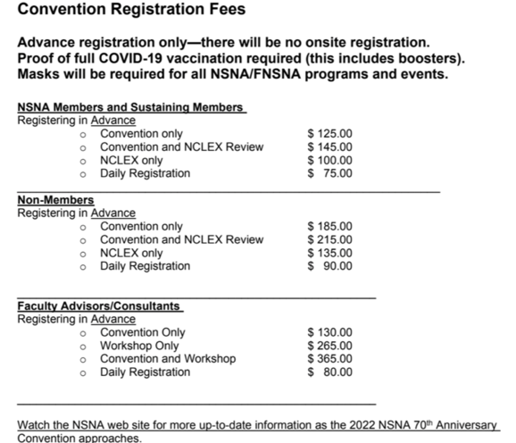  - Hotel:  - They give 4 hotels as options and the hotel reservation form deadline is due by March 7. The hotel requests are first-come first-served so the sooner the form is filled out the better.  - Convention location: Salt Palace Convention Center  - Hilton Salt Lake City Center: 1 min walk (shuttle service)  - Would be our best option because it is the closest to the convention center, along with not being the least/most expensive.  - Salt Lake Marriott Downtown at City Creek: 3 min walk  - Salt Lake Plaza Hotel: 5 min walk (shuttle service)  - Radisson Hotel Salt Lake City Downtown: 8 min walk  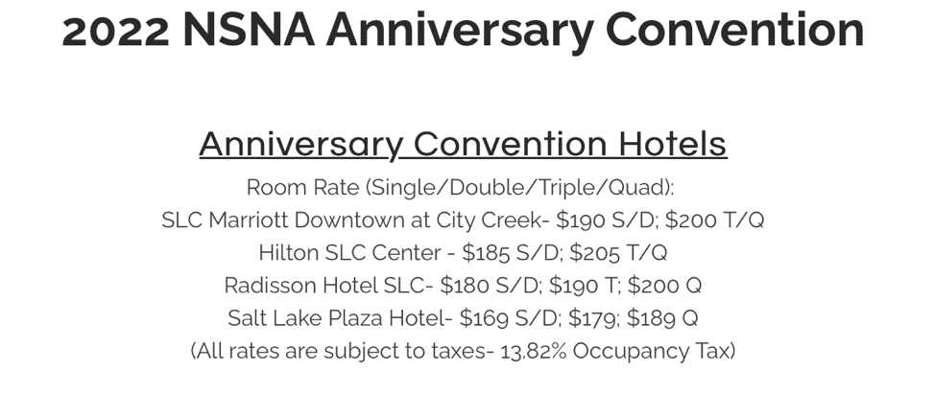  - Flights:  - NSNA arranged a discount code with Delta but they don’t have the code yet  - I went on delta to see what round trip would roughly cost. I selected April 5- April 10th (day before convention and last day of convention.) The prices ranged from $300-$350 without the discount.  - QUESTIONS:  - How did past conventions work in terms of which day they got there and which day they left?  - We would need to leave April 5th, the night before the convention, and come back on Sunday morning, April 10th.  - Lauren, I know both of us only saw Chloe and Josee request funding for online national convention, but do you by chance know how funding was requested in the past with flights? I know we have to give numbers in our presentation, and everything is a definite number besides the flight.  - We will over estimate on price of flights for funding so that we don’t cut our self-short on funding since we are not sure what the prices of flights would be.  - Transportation:  - How did transportation to and from the airport work in past years? I talked to a charter bus company and they quoted us for a minibus with a driver that fits 16 people at $795 for the ride from the airport to the hotel, and back to the airport. They gave us 10% off for being a nonprofit, but we also have to tip the driver 10-20% of our total cost ($79.50 - $159)  - The minimum hours per day we can rent that minibus is 5 hours. I figured once we get the itinerary for the convention we can all plan out what we want to do for fun and I can see if we can rent the bus for those days and times, or maybe the shuttle services at the hotel might take us.  - I only called one bus company, so maybe a different company wouldn't have a minimum number of hours to be rented per day, which would make the cost cheaper.  - Would probably be cheaper for us just to Uber everywhere we go.  Sample budget (does not include flight):  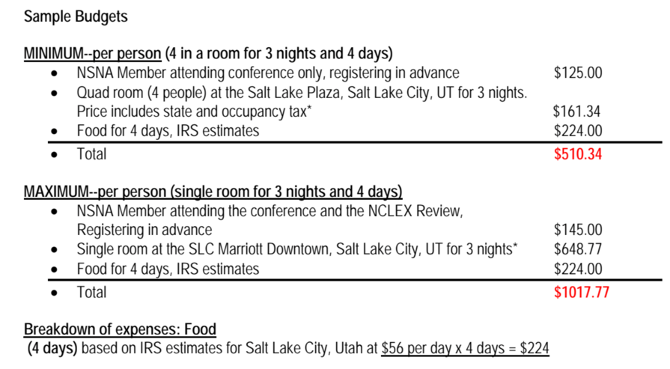  - National convention registration form:  - SNA covered half of non-board member’s tickets in the past, I figured we would do the same this year. I will send a google form into the GroupMe within by tonight or tomorrow since we need to start our request for funding from SGA.  - Question:  - In the interest form should I just say that prices are not fully set but give them a rough estimate after we choose which hotel we want to stay at and that we will cover 50%?  - Will be best to see how many people say they are willing to attend before we decide on how much we will cover of non-board members.  - Mrs. Dorminy, do you think the students filling out the form and emailing you requesting permission went smoothly for state convention, or should I change something for nationals?
Secretary:  Caroline Porter | - Approve November Board Meeting minutes  - Kahoot game  - Next CC meeting TBD  - Will cover the cost of the guest speaker gift cards |  | **VOTE**  Caroline makes a motion to approve the November 2021 Board Meeting minutes.  Erin seconds.  Motion passes unanimously.
Legislative Director:  Lauren Fuller | - Convention schedule - TBD  - Convention Delegates  - One voting delegate and alternate, and an additional voting delegate and alternate for every 50 members.  - 3 delegates and 3 alternates – for our approx. 120 members  - Convention Funding  - CRT Senate Bill 12 weeks before funding - through KnightConnect. Start this week.  - 2 officers who have completed the RSO financial training need to fill out the form and attend committee meetings to present.  - https://studentgovernment.ucf.edu/wp-content/uploads/sites/4/2021/03/CRT_Committee_FAQ_Sheet.pdf - information and instructions for funding request.  - Flights - can be requested through the Senate Bill funding as well as registration/lodging costs.  - Previously a set number of funds needed to be used, but now it is not stated. I can reach out to confirm the amount of funds needed to be used, but I think we should estimate on the higher end for flights.  - Estimate - with Hilton SLC 4 quad rooms, high end for flights ($350 per person), and seniors/accels attending NCLEX prep:  - $8185.00 (with SGA covering 50% = $4092.50)  - Not including food/other activities for the purpose of SGA funding request  - Convention Tabling  - $35.00 fee for a 4 ft table and 2 chairs  - This would be the fee for tabling the whole convention.  - Publications/Guidelines for Planning: Fundraising.  - https://www.nsnaconvention.org/student-activity-tables.html - request a table  - Scholarships through the Foundation of the NSNA.  - https://www.forevernursing.org/2022-online-scholarship-application-fact-sheet.html  - Stellar School Chapter Recognition  - Stellar School Chapter Recognition Criteria Categories Description  - We are currently listed as a Stellar School. Does anyone know when this occurred? We need to renew after 5 years.  - We were recognized in 2019.  - Other than this, I couldn’t find any other chapter awards, maybe they will be published with the convention itinerary?  - Finals technically start on 4/27, is that an ok day for the April General Meeting, or should we maybe move it to the week before?  - The April General Meeting will be changed to 4/20/2022 so that it does not interfere with finals week.
Clubhouse Director:  Alexandria Moran | - Finishing up the Spring merchandise order proposal. I will have it done by the general meeting at the end of this month. Is everyone able to stay after the meeting for a few minutes to vote on the matter?  - We will hold an emergency meeting to vote on this matter.  - Any updates regarding convention? Still in-person?  - As of now convention is still in person, and the convention schedule has just been posted.  - Was it ever decided how committee members could be added for new committees? I am interested in forming a Clubhouse Committee  - There will be an application form for the committees and then the board will vote who will be on the committees.
Accelerated Liaison:  Emily Jones | - Working on getting ready and organizing information for our cohort’s composition photo - so excited!! (:  - This will be held on February 2nd.  - Attendance of Curriculum Committee Meetings  - This month’s CC meeting was canceled.  - Need attendance dates to be forwarded  - Continuing advocating for SNA and joining our organization
Media Director: Sarah Stukey | - Lifeline Newsletter  - Submissions for January due on the 16th  - Need two people who are willing to write articles for this edition  - Include pictures and references!  - The sheet to sign up for upcoming months is still posted in the Facebook  - Please continue to send student and faculty spotlight nominations  - Bluehost renewal coming up for the website and it will have to be voted on in the next board meeting  - $95 renewal fee
Historian:  Cynthia Fonseca | - Relay for Life  - March 19th-20th  - I created a team for SNA and plan to announce it and share the signup link at the January meeting  - I am currently working with Maxwell Jones, a junior, who will be our honoree for our team to plan a theme and fundraising ideas  - Here is the link for our team if any of you guys want to sign up :) http://main.acsevents.org/site/TR?team_id=2613538&pg=team&fr_id=101669&s_locale=en_US&et=f0V0voBlFICdRLeI-2pi4RydPZw-wnTcgBaaxwi2QdPqNnjDFA9HxA&s_tafId=2405139  - Kickball Event  - Megan and I plan to work together to plan the annual kickball event  - More details TBA
Breakthrough to Nursing Director:  Samantha Maiolo | - Email sent to Seminole High School to follow up on interest  - Student Nurses Day / Week Celebration  - Want to plan a celebration week of events  - If anybody has any ideas feel free to send them over!  - CON Tour?  - University High School Interest, should it be exclusive or open?  - Rules on visitors due to COVID?  - Will have to check University guidelines to see if we are still able to hold this.
Community Health Director:  Peyton Hawks | - January Volunteering:  - 1/9 volunteered with the CFDMT at the Walt Disney World Marathon where we learned about how they prepare for mass casualty events and provide medical support for sick and injured runners.  - Apopka clinic volunteering with Peralta was canceled this month because of the rise of COVID cases. Hopefully she’s able to run the clinic again before the semester ends.  - Knights pantry food drive. Leave a box for donations in 602 and make the last day for donations on the same day as our January general meeting.
Fundraising Chair:  Megan Fleming | 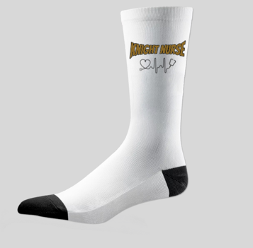  - January Fundraiser:  - Selling Knight Nurse socks  - Fundraiser closes on January 24th  - I planned on doing a quick vote after our meeting on the 26th for the price approval so I can place the sock order  - February Fundraiser:  - I plan on making a Valentine’s Day basket raffle
Advisors:  Kate Dorminy  Brian Peach | - The CON will cover the full cost of all advisors to attend National Convention, so SNA does not have to cover their cost.  - Dr. Peach will reach out to Sunny to see if we need to book Dr. Peach, and Mrs. Dorminy’s hotel reservation with ours.

