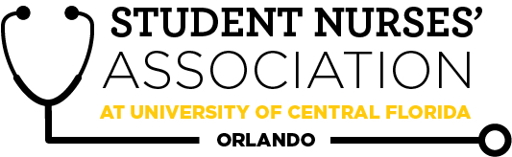 |  |  |  | Student Nurses’ Association at UCF Orlando – JAN General Meeting MINUTES  Time Called to Order: 1701  Time Adjourned: 1900  Location: Zoom  Presiding President: Samantha Cooney  Recorded by: Amanda Shover
Attendees Present: |  | Samantha Cooney, Chloe Frye, Sadie Richards, Hope Wegge, Amanda Shover, Josee Etienne, Amber Keller, Audrey Been, Natalie Klosinski, Delaney Dietz, Megan Donnelly, Leah Utt, Kate Dorminy, Brian Peach, Lauren Fuller, Erin Tonkin, Monique Csenteri
Attendees Absent: |  | Kate Dorminy, Natalie Klosinski
Presenter: | Agenda Item/ Discussion |  | Action: |  | Follow-up:
Samantha Cooney- President | - General Meetings  - January 27th  - February 24th  - March 31st  - April 21st  - Board Meetings  - February 2nd  - March 2nd  - April 7th (first night of convention)  - New redistribution for weekly mentor meetings:  - Dr. Peach: President, Treasurer, Legislative Director, Fundraising Director, B2N Director, Media Director  - Ms. Dorminy: VP, Community Health Director, Clubhouse Director, Accel Liaison, Historian, Secretary |  | Vote:  Future meetings (Board/General) in person or virtual?  **VOTE**  Samantha makes a motion to vote on having future monthly board meetings held virtually.  Chloe seconds.  Motion passes.  ** VOTE**  Samantha makes a motion to vote on having our January general meeting in person.  Josee seconds.  Motion does not pass  Votes for= 6.  Votes against= 4.  January General Meeting will be held virtually.
Sadie Richards- Vice President | - January general meeting 1/27  - Guest speaker: Anthony Winston, CRNA  - Will this month’s meeting be F2F?  - Follow up on sponsor- they offered to raffle two $50 gift cards.  - We will split up the $100 into 4 $25 prizes to be given to the top point Kahoot player at each of the next general meetings for the semester.  - Potential guest speakers  - Lisa Bowman- Chief Nursing Officer at AH Women and Children’s Tower.  - Darleen Williams- ED Nurse Specialist ORMC. Gave great presentation about Pulse  - Thomas Weichart- Former White House RN, former military RN, and current NP.  - AACN-MOC Orlando Board Members.  - Aaron Johnson- Pharm. D student interested in presenting on the "Interprofessional Teamwork in the Healthcare Sector".  - Break out rooms.  - Great feedback. I will continue to incorporate them in future meetings.  - SNA Points  - Points are up to date  - Remind students to use their first and last names when signing on to zoom meetings and when volunteering.  - Officers- When completing the form for volunteer events, please remember to include the number of hours for each student next to their names. |  |  |  | Waiting for a reply from the sponsor to confirm attendance at the January General Meeting. Sadie will let us know ASAP.
Chloe Frye- Treasurer | Current Balance: $16,131.14  Current Membership Count: 139  - UWorld get the ball rolling? Certain people have approached me and are looking to buy it before February.  - Taxes  - 501 c3  - Recommend to seek council from a CPA to help us seek tax exempt and help straighten out taxes  - Also want written guidance on how to proceed with taxes in years to come  - National Convention is coming up soon April 5-10 2021  - SGA funding? Is it possible at this point?  - Pay for the convention and NCLEX review for the senior board members and accels.  - Do we pay for convention and faculty workshop for the advisors? Decision made by the board at a future date.  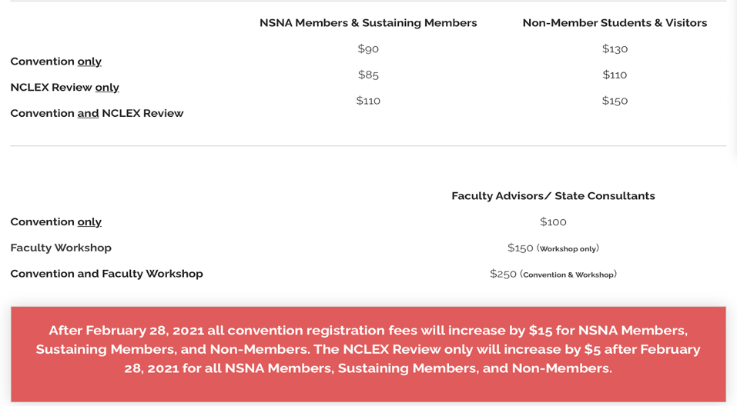  - We have the ability to sell merchandise through a student activity tile. We would be responsible for shipping. But it may still be a profitable option and we could do a raffle basket.  https://www.nsnaconvention.org/student-activity-tiles.html |  | **VOTE**  Chloe makes a motion to seek counsel from an outside source (CPA, H&R Block) to help straighten out taxes.  Samantha seconds.  Motion passes.  Begin advertising national convention and send out an interest form to the rest of our organization at the January general meeting. |  | Hope is waiting for response from UWorld sales team regarding pricing for group rates, and she will get back to us when they answer.  Dr. Peach & Mrs. Dorminy will look more into what the faculty workshop at national convention entails to further decide at the next board meeting.  Further discuss at next meeting whether or not we will pay for our members to attend national convention.
Leah Utt- Clubhouse Director | - Inventory updated  - Sweatshirts have been ordered  - Still unsure of EDD  - New supplier for our future purchases!  - Booster Spirit  - Automatic invoices  - 15-day turnaround  - Used by Knightthon  - Similar pricing to our previous supplier  - Instant quotes  - Handing out badge buddies during Skill days  - Envelope attached to SNA cork board  - Juniors p/u during Wednesday skills 1/13  - Accels p/u 2/2  - Seniors p/u TBA  - Tabling for accelerated class on 2/2 during composite photo day  - Future tabling if we have in-person meetings  - Poll members at the January meeting via Zoom to see what they would be interested in?
Megan Donnelly- Accelerated Liaison | - Curriculum Committee Meeting 1/12  - Accelerated Composite Photo Day 2/2  - Updating class roster by 1/25  - SNA table set up at event  - Thoughts on ways to donate remaining $415 from Accelerated class on behalf on Mrs. D?  - Scholarship fund, etc.?
Josee Etienne-  Legislative Director | National Convention  - UPDATE: Has been changed to virtual  - I did stop the financial process for flights and hotel stays  - However, Chloe, Samantha, and I talked about if SGA can finance the registration fee since it is slightly pricey  - Awaiting updated forms to be uploaded on the SGA website (2021-2022) I emailed the finance office  Resolutions  - You are still welcomed to submit a resolution for national convention, now that you have a better understanding of what they entail.  - I will be updating the state one to specify it towards national status.  Election  - Spring (7 positions are open to Junior SNA members)  - VP  - Secretary  - Historian  - Media director  - Community health director  - Breakthrough to Nursing director  - Fundraising director  - I will work personally with Lauren to ensure a smooth election.  - Best date option: February 24th meeting  - It will provide enough timing for submissions and training once elected.  - I will announce the position on the 27th and would have the media director and Lauren’s help to advertise.  - I also encourage each position to also talk about their responsibilities at the Jan meeting. |  | **VOTE**  Josee makes a motion to have the Spring 2021 elections on February 24.  Samantha seconds.  Motion passes. |  | Waiting for email from SGA to proceed with forms to be able to receive money to cover registration fees for national convention. Josee will report back when she hears from them.
Hope Wegge- Fundraising Chair | Chick-fil-a fundraiser  - AMAZING turnout!  - Profit: $60  Blaze Pizza Fundraiser  - Tuesday, January 19th (already secured)  - ALL DAY!  - We have to bring in $200 minimum in order to receive a profit  - In-person OR online pick-up!  - Advertise through social media, listserv with flyer provided by Blaze  - Show flyer in person or type in code for online pick up  Valentine’s Day Grams (February)  - Price: 1 for $2 or 3 for $5  - Payment via Venmo or Square app  - Sell in person 1 day?  - Who: students and faculty  - What: assorted candy/goodies with a sweet message (all pre-wrapped items)  - “You’re Sweet Like Candy”, “You Make My Heart Burst”  - Cost: Pre-order via google form  - ~$0.50/gram  - ~$60 in supplies (depends on # of orders)  - Advertise via social media, listserv, class (zoom)  - Assembled with the help of board members  - Delivered the week before Valentine’s Day  - Staff: office numbers  - Students: pick up themselves?  - Are bake sales still not going to be planned this semester?  - I contacted UWorld about NCLEX discounted group rates |  | **VOTE**  Hope makes a motion to hold a Blaze Pizza fundraiser on Tuesday January 19th.  Chloe seconds.  Motion passes. |  | Hope is going to get in touch with SGA to get approval for putting candy items in a raffle basket for February’s fundraiser.  We are going to put the Valentine’s Day Gram on hold, and we are potentially going to do another raffle basket in place of the grams. Further discussion will be held at the next meeting.
Natalie Klosinski- Breakthrough to Nursing  Director | - I want to start organizing virtual CON tour if anyone would like to help  - University HS teach in event- did one in December and waiting for follow up to potentially do another  - APNS event: helping them with application & do a Q&A panel  - Oviedo HS premed club going to follow up on at the next board meeting
Amber Keller- Media Director | Next Newsletter Submission Deadline is January 17th  Include pictures or references  Chloe  Audrey  Hope  Let me know any nominations for spotlights!  The domain for the SNA website has been renewed with Bluehost through March 6th, 2022.
Audrey Been- Historian | Ordered Luminaria bags for Relay for Life  → picking up the bags tomorrow  Selected Relay for Life team theme: Lights, Camera, Cure  “The Knight Shift”  Looking out for next Alumni Chapter meeting date
Delaney Dietz- Community Health Director | - RMH Donation Collection  - Wednesday, 1/27, in the AM  - Straight Street  - 1/19 or 1/25 (waiting on confirmation)  - Knight-Thon is on 3/27  - No confirmation if it is virtual or in-person  - Possible fundraiser night at Blaze or Chick-fil-A next month?
Amanda Shover- Secretary | - I will take on the Kahoot questions for the January General Meeting  - Willing to help anyone on any upcoming projects  - I still have a $15 Starbucks gift card in my box from last year if we want to award that at a future meeting!  - CC Meeting today
Advisors:

Kate Dorminy

Brian Peach

