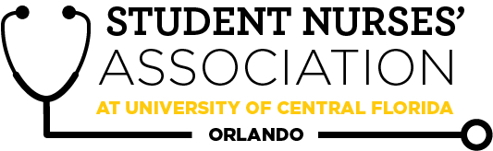 |  |  |  | Student Nurses’ Association at UCF Orlando – JUNE General Meeting MINUTES 6/24/20  Time Called to Order: 1701  Time Adjourned:  Location: Zoom  Presiding President: Samantha Cooney  Recorded by: Amanda Shover
Attendees Present: |  | Samantha Cooney, Chloe Frye, Sadie Richards, Hope Wegge, Amanda Shover, Josee Etienne, Amber Keller, Audrey Been, Natalie Klosinski, Delaney Dietz, Megan Donnelly, Leah Utt, Kate Dorminy, Brian Peach, Monique Csenteri, Erin Tonkin, Lauren Fuller
Attendees Absent:
Presenter: | Agenda Item/ Discussion |  | Action: |  | Follow-up:
Samantha Cooney- President | - Good luck to the Juniors running for a position tonight!  - Upcoming events:  - Knight thon!  - March 20th  - National Convention  - April 5th-10th  - Virtual experience  - SNA Cords  - For Seniors…Top 3 SNA point earners get a free cord!  - Our next general meeting:  - March 31st at 1700
Sadie Richards- Vice President | - Welcome to the February 2021 Meeting!  - Please welcome our guest speakers:  - Nadine Walker, MSN, BSN, RN C-EFM  - Regional Director of Women Services, Advent Health Orlando and Altamonte  - Wanda Escoffery, MSN RNC-NIC, NE-BC  - Executive Director of Nursing for Pediatric Network & Operations.  - Robyn Muyet, MSN RN CPN,NE-BC  - Director of Nursing for Pediatric Acute Care Services  - Next meeting will be held on March 31st at 1700  - Good luck to each of you who are running for a position today.  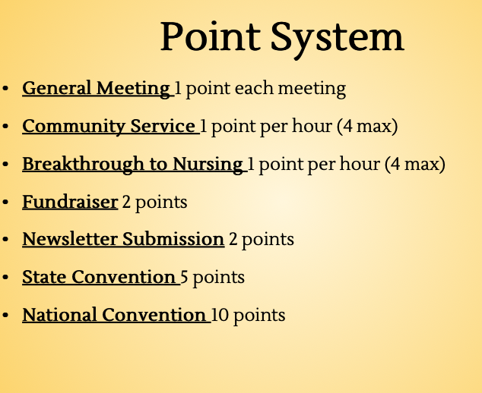
Chloe Frye- Treasurer | Upcoming Expenses  - Continued membership enrollment  - National Convention  Bank Balance: $17,085.95  Membership Count: 141
Leah Utt- Clubhouse Director | - Sweatshirts have arrived!  - Tabling at in-person SNA meetings  - Also tabling virtually at national convention  - Website coming soon :)
Megan Donnelly- Accelerated Liaison | - Welcome to the February General Meeting! SO happy to be here in person with some of you all!  - Accel Cohort Composite Photo Day was a success- thank you to everyone who participated!  - Curriculum Committee Meetings  - Attended last meeting on 2/9  - Next one TBD in March  - Please reach out to me if you have any topics or concerns!  - GOOD LUCK to everyone running for a position tonight! You’re going to do awesome :D
Josee Etienne-  Legislative Director | Happy Election Day !!!  Welcome to our February general meeting  National Convention  - April 5th-10th  - Virtual experience  - Looking forward to attending and being a part of yet another great networking event.  Election & Voting Process Review:  - Each candidate will deliver their one-minute (60 seconds) elevator speech. Josee will time for exact 1 minute in which candidates will turn on their camera (if running from Zoom) or get in front of the camera in-person  - Nominations will also be accepted from the floor  - If you know anyone who would be interest in running but did not get a chance to submit their bios, they can be nominated right now and deliver their elevator speech as well.  - We will then vote for our desired candidate for each position  - Results will be announced at the end of the meeting  - ONLY PAID UCF ORLANDO SNA MEMBERS ARE ALLOWED TO CAST IN THEIR VOTES.  GOOD LUCK!!!!
Hope Wegge- Fundraising Chair | - Thank you to everyone who entered into the Valentine’s Day Basket Raffle! We made over a $300 profit because of you guys!  - UCF Day of Giving / Senior Class Gift  - Consider paying it forward & leave your legacy by making a class gift (donation) this year!  - Earn a green cord for graduation / recognition for $20.21 donation  - Everyone is welcome to participate (students, faculty, alumni, family)  - Participation is key vs. amount donated  - Date + link will be shared at later date  - Scholarship/memorial involving Mrs. D will be incorporated – SPECIFY this  - Good luck to all juniors running for a position tonight !!! :)
Natalie Klosinski- Breakthrough to Nursing  Director | - Virtual CON Tour in March- pre-nursing students, high schoolers  - If interested in volunteering, contact Natalie via email  - Oviedo HS Medical Club Skills Demonstration and Q&A panel  - most likely face to face (with safety precautions of course)  - date TBD → March  - Good luck to everyone running for positions tonight!
Amber Keller- Media Director | - Last newsletter submission deadline of the semester is April 18!  - Can be an academic submission about a skill or pathology!  - Can be about a nursing school experience!  - Anything healthcare or nursing related!  - Include photos and references!  - Contact me with Student Spotlight  Nominations via email!  - Good luck to those running for positions today!  - Follow us on social media:  - Insta: @snaucforlando  - Facebook: The Student Nurses’  Association: UCF - Orlando
Audrey Been- Historian | - Seniors, continue to gather photos from the last two years for the graduation video.  - Dropbox or google drive link will be shared on GroupMe soon.  - Join our Relay For Life team!  - $330 raised so far
Delaney Dietz- Community Health Director | - Thank you to those who donated to and volunteered with Straight Street this month!  - Knight Thon  - March 20th  - $250 Dancer Commitment  - Sign up still available- 4 hours long on Saturday, March 20th  - I will send out registration this week through GroupMe for those interested  - Collection drive for RMH  - Mid-March  - Good luck to the Juniors running for positions!
Amanda Shover- Secretary | - Welcome to the February General Meeting!  - GOODLUCK to all running for a position tonight!!  - Attended the CC meeting on 2/9  - Next CC meeting in March TBD  - Reach out to Megan or myself if you have any topic relating to our curriculum you want to be addressed!
Advisors:

Kate Dorminy

Brian Peach

