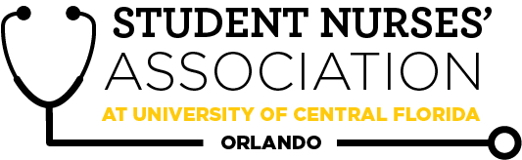 |  | Student Nurses’ Association at UCF Orlando – JUNE  Board Meeting MINUTES 06/01/2021  Time Called to Order: 1700  Time Adjourned: 1824  Location: Zoom  Presiding President: Erin Tonkin  Recorded by: Caroline Porter
Attendees Present: | Erin Tonkin, Vanessa Iturri, Monique Csenteri, Caroline Porter, Lauren Fuller, Leah Utt, Sarah Stukey, Cynthia Fonseca, Samantha Maiolo, Peyton Hawks, Megan Fleming, Kate Dorminy, Brian Peach
Attendees Absent: | Megan Donnelly
Presenter: | Agenda Item/Discussion: |  | Action: | Follow-up:
President:  Erin Tonkin | - Board Meetings:  - Tuesday August 3rd  - Tuesday September 7th  - Tuesday October 5th  - Tuesday November 2nd  - General meetings:  - Wednesday June 30th  - Wednesday August 25th  - Wednesday September 29th  - Wednesday October 27th  - Wednesday November 17th  - Junior Orientation: In person on August 19th!  - Officers will be going  - I have reached out to SGA and Webcourses for club re-registration and training are not yet available, but will be by the end of the month so be on the lookout. Are we okay with President, Vice President, Secretary, and Breakthrough to Nursing Director being the four “official” officers for RSO?  - Everyone was in agreeance of these being the four “official’” officers  - Monique did the financial training during National convention  - Junior Meet & Greet: Thursday, June 3rd from 2:30-3:30pm. Will be held on Zoom. This could be a great opportunity to talk about SNA!  - Mrs. Dorminy needs 2-3 more people to go and talk. If you can go please email here as soon as possible.  - Should our board meetings continue to be on zoom?  - A poll was taken and the majority said they would like to continue with zoom board meetings.  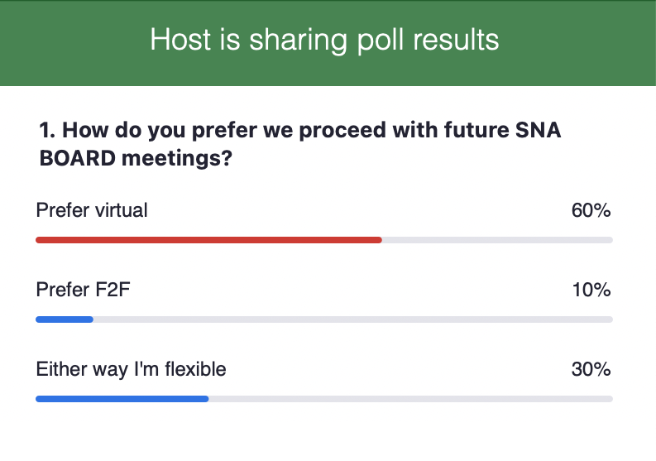
Vice President:  Vanessa Iturri | - June 30th General Meeting  - Guest Speaker  - In contact with Mrs. Gonzalez,  - Ms. Sara Rose Thornton: NICU/ICU  - Lisa Bowman: Chief Nursing Officer at AH Women and Children’s Tower  - Both will be guest speakers at the next general meeting  - Mode of Meeting: Vote  - Need to check bylaws to see if votes for election have to be anonymous or not if we are going to have a virtual aspect of the meeting so that we can make sure everyone who voted was in attendance to the meeting.  - http://www.snaucforlando.com/bylaws-2/sna-at-ucf-orlando-2020-2021-bylaws/  - Food?  - Due to the pandemic and the current state we are not allowed to have food unless we get the proper approval, we need to be registered as RSO officers before we can push it forward  - Erin will share the results to the dietary poll done at the last general meeting with Vanessa to coordinate for future meetings if we have food  - Assigned duty list if meeting is in-person  - Erin and Vanessa will work together on this and coordinate it all out  - Results of “Guest Speaker” survey  - Travel Nursing  - Nurse Practitioner  - Pediatric Nurse / L&D / OB  - CRNA  - Junior / Senior Buddy Program  - Information will be sent out prior to the next general meeting  - Sam will discuss this more later on  - Elections after Kahoot Game?  - Just need to make sure that we have time to tally the result and they are sent to the board for approval before they can be announced  - Vanessa and Lauren will work together this week to coordinate the best time during the meeting for when the voting should be held.  - June 3rd Meet & Greet |  | **VOTE**  Vanessa makes a motion to have the June General meeting in person with a virtual option.  Lauren seconds.  Motion passes unanimously.
Treasurer:  Monique Csenteri | Current Balance: $17,152.83  Current Membership Count: 151  - Tax update:  - No new updates since the last board meeting. Still waiting on an email from Mr. Scott.  - Friendly reminders:  - All board members must sign the last page of the bank statement, financial report, and Venmo report. They are available now! Please have these signed by 06/02/2021 @2359.  - May Financial Report:  - https://drive.google.com/file/d/1on-YDgR0YSJorFEvcAj0MF3C-p7nB-qp/view?usp=sharing  - May Bank Statement:  - https://drive.google.com/file/d/1MZKn5XwWihYzoDZPnIa2RQ4ZLPOiG77h/view?usp=sharing  - May Venmo Report:  - https://docs.google.com/spreadsheets/d/1HVWiav_BaP7iYUws-12LFYf7wRfWAjRWc0_ioxe_3iU/edit?usp=sharing  - Receipts:  - https://drive.google.com/drive/folders/1kqnwXsnW1Hi2W2p-6ZqL0Dkv7KDS2L_t?usp=sharing  - 2 officers at the cash box at all times  - All officers can accept membership forms  - Must provide a receipt to get reimbursed  - Encourage Membership all you can!  - Bank Card must be signed in and out in order to use it  - https://drive.google.com/file/d/1u439614tCTrTMVzOSIbq2wuMmCwzXGC6/view?usp=sharing  - EVERY purchase made with the SNA card REQUIRES a receipt to be sent to the treasurer within 48 hours of purchase  - Every purchase under $50 requires the president’s approval and every purchase over $50 requires a vote from the board.  - I had a NSNA member (one year membership of $37) who is a second degree BSN student at UCF reach out to me wanting to join UCF SNA. How should I go about charging them? Should I only charge the $10 fee for our local chapter?  - Our full dues are $47 ($37 for NSNA, and $10 for our local chapter)  - Everyone agreed that she should only charge him $10 since part of our dues go toward registering members with NSNA, and he is already a member with them so that would cover the fee for him to join our local chapter  - I would like to start working on finding a hotel for state and national convention, and I was wondering who would like to help me.  - Lauren said she would help  - What day is the state convention? I had trouble finding information on state convention.  - Dates have not been announced yet, Lauren will let us know if she finds out an update on dates  - Dr. Peach believes it is usually the last week in October, he will reach out to the executive director to see if he can get the dates for us.  - Sarah, would we be able to update the membership form on our UCF SNA website because it is outdated?  - Sarah is going to update this form on our website  - Unfortunately, I was unable to be present when badges were discussed in the last board meeting. There is currently no designated area in the budget for badges, but I can edit the budget to include badges if we decide they should be funded by SNA.  - Dr. Kenneth Dion, who is a UCF alumni, won a $25 Amazon gift card in a raffle and decided to donate it to our SNA chapter. What would we like that to go towards? Dr. Peach, Erin, and I thought a new kickball could be a good idea.  - Dr. Dion also decided to match another $25, so we actually have $50 to spend  - He is mailing a check to CON very soon  - Open discussion to any ideas as to what we could spend this money on instead, or we can save it for a later time  - No final decision has been made as to how to spend this money
Secretary:  Caroline Porter | - Here is the link to the google calendar I made for us!  - I went through and added notes to event such as zoom links and what events will happen at these meetings  - Will continue to update it as we move forward  - https://calendar.google.com/calendar/u/1?cid=dWNmc25hb3Jsc2VjcmV0YXJ5QGdtYWlsLmNvbQ  - Bulletin/white board outside the clubhouse being used?  - Post a calendar there for members to see when on campus  - Hasn’t been updated for summer but if anyone wants to, please feel free  - Next CC meeting TBD  - Will make Kahoot game for the next meeting  - Vanessa will purchase thank you gift cards for the guest speakers this month  - Mrs. Dorminy and I were discussing how to get more student feedback to present at curriculum committee meetings some ideas were surveys, or small peer review groups  - Peer review groups were the favored idea among the board  - Groups can be made from random selection or students who volunteer  - Need to vote to approve the minutes from both April and May board meetings, can be found on the Facebook page. |  | **VOTE**  Caroline makes a motion to approve the minutes from both the April and May Board Meetings.  Monique seconds.  Motion passes unanimously.
Legislative Director:  Lauren Fuller | - Upcoming Elections at the next General Meeting. Already received one bio, encourage anyone interested to run!  - Going to wait till all the bios are in before Lauren sends them to advisors for approval  - Dr. Peach and Mrs. Dorminy offered if anyone wants to come speak to the accels about running for a position feel free to come and speak before one of their classes.  - Timing for elections during the meeting - need time to tally votes and confirm with the board with results  - Lauren was thinking it would be better to wait till after the speakers for the elections, she will coordinate with Vanessa  - Work with Sarah on Instagram post for elections?  - Also preparing email to go out for elections to accel class  - Potential Q&A with former SNA members on the process of resolutions at state and national convention.  - Has had a few people asking about the process and what goes into it  - Let Lauren know if anyone or someone you know is interested in making one  - Was thinking about having Chloe and Josée come back and speak at one of the general meetings or doing a separate Q&A about the process
Clubhouse Director:  Leah Utt | - Tabling at Parent’s Orientation (Date TBA)  - Welcome letter to incoming juniors on June 3rd  - Will there also be a PowerPoint for this? I would like to add a slide if so!  - Clinical supplies  - Probably will need an emergency vote :/  - Does anybody have anything they want to add i.e. mentor pairings  - Vanessa and Leah will work together to create one big email to send to all the new junior’s information about joining SNA and ordering clinical supplies  - I will also work on a word document to pass on to my replacement with all the info needed to succeed in this role :)  - Senior cords:  - Need 2 leadership cords for top point earners (1 left over from last semester)  - 25 in stock, 36 accels in SNA not including myself, Megan, and top point earners  - Preorder to see how many people are interested?  - Last semester we sold 18  - We do not make any profit off these cords so we would not be at a loss if we end up buying them from SNA we would just break even  - Preorder is a good idea, if more than 25 people are interested let’s just order more and then the remaining 25 we will have to find a later use for them
Accelerated Liaison:  Megan Donnelly | - Accelerated Liaison duties PowerPoint is complete and ready to be passed on to the new elect when they join the board on June 30th!  - The Mentorship Program has received great feedback!  - June/ July Curriculum Committee meetings TBD?  - Pass on contact for leftover badge reels in Clubhouse - Delaney: 561-886-8064  - Access to an Accelerated Liaison email account? I have always just used my personal email since I never received any login information when I was elected.  - A new email for this position will be created after the new Accelerated Liaison is elected
Media Director: Sarah Stukey | - Newsletter  - Please continue to sign up for months to write an excerpt in the newsletter! I would be really appreciative if each of us can sign up for 1-2 and encourage our classmates to as well  - Next submission deadline: June 20th  - November submission deadline has changed to Nov 19th  - Student/Faculty Spotlights have been sent for this month  - Thank you to Mrs. Dorminy for recommending a few students and professors! I would love to continue collecting recommendations so we can have a bank of student responses to use in the newsletter!  - Still collecting photos for website  - Send photos in CON polo, with a white background  - Discussion of Back to School BBQ interest and ideas  - Want to gauge more on if we will be holding this event and the types of safe forms we need to begin to fill out  - Cynthia will speak more on this
Historian:  Cynthia Fonseca | - July 27th- Alumni board retreat  - Back to School BBQ  - Collab with Sarah  - More info TBA  - Start getting ideas together of what we want to do, not so much get things in motion because it's probably best to wait till we get the RSO conformation and see what the logistics of this school year are going to look like with the types of approvals we need  - Mrs. Dorminy suggests/reminds that part of this role is taking photographs up until graduation and creating sort of a collage for us to all look back on and they BBQ is a great place to start as we get back into being in person
Breakthrough to Nursing Director:  Samantha Maiolo | - Email to Contacts Complete  - Junior - Senior Buddy Program  - Send Link: June 3rd (Meet & Greet)  - Due Date for BOTH cohorts: June 17th  - Send Buddies: June 24th  - Advertise to meet their buddy at the June 30th General Meeting?  - Junior-Senior Buddy Google Form Link:  - https://docs.google.com/forms/d/1pwqVg4VfZCr80ynmq28jXkVCLOFiLnq6LsTqqyGAlTg/edit?ts=6091c4da  - Psychomotor Skills Booklet from Dr. Hoyt & Mrs. Drohan?  - Don’t really have any need for it at the moment, Sam is going to hold on to it in case it comes up in the future.
Community Health Director:  Peyton Hawks | - Oakland Nature Preserve volunteering 6/26 8-11AM  - Only 10 spots available  - Sign up deadline is 6/14  - Senior Citizens Connection program runs 6/28-8/1  - Pair up with a Westminster resident and have a 20 minute phone call once a week for 5 weeks.  - If you are interested please sign up! We are aiming to have at least 15 students sign up so there's enough pairs.  - Residents love this program!
Fundraising Chair:  Megan Fleming | - June  - Partial Proceeds with Chop 5  - Date is TBD  - July  - Yard Sign Fundraiser  - For the 2020 Knight Nurse accel cohort graduates  - What is their graduation date?  - August 7, 2021  - I’d like to try to make the sign very general so it could apply to multiple cohorts  - Parents, family & friends can buy one  - Buy through “preorder”  - Whoever would want one would buy it ahead and then they’ll be ordered from the printing company, right now I’m looking into imprint.com  - August  - Hugs from Home care packages  - I want to advertise them during the parent’s orientation- what are the orientation dates? Are they going to be in person?  - Dates/Place have not been set yet  - Historically has been in person on the same day as the junior’s orientation day  - Students/parents love this  - Mrs. Dorminy suggested staggering some of these care packages (i.e. first day of school, first check off, etc.)  - Ideas for how to advertise for fundraisers? How do I reach out to the alumni population and our current cohort’s family members (such as parents)?  - Reach out to Mrs. Judy and see if she has an email list for the parents of the new cohort, also reach put to Lisa Goldblatt and she at the very least could tell you best way to go about reaching out  - I’d like to shout-out Monique, Cynthia, Erin, and Mrs. Dorminy for participating in my most recent fundraiser and buying Instagram shout-outs!! I think officer involvement is very important and would be really encouraging to other students to want to participate if their friends were involved. So please try to participate in fundraisers and spread the word about them to all your friends, because if we’re not participating in them we can’t expect other students to want to do so. The success of our organization and our fundraising starts with us so please try to get involved!!
Advisors:  Kate Dorminy  Brian Peach | Dr. Peach:  - How early can we send in a request to RSO for funding for state and national convention?  - Not really an early date  - Want to keep in mind how many delegates we will be sending  - We can only file once so we want to apply for funding for the National convention  - Erin has a very detailed book from the 2016 SNA President about how to get this funding, she will look more into this

