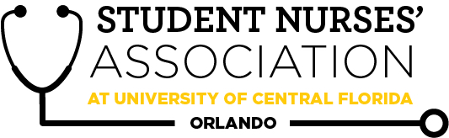 |  | Student Nurses’ Association at UCF Orlando – AUGUST  Board Meeting MINUTES 08/03/2021  Time Called to Order: 1701  Time Adjourned: 1904  Location: Zoom  Presiding President: Erin Tonkin  Recorded by: Caroline Porter
Attendees Present: | Erin Tonkin, Vanessa Iturri, Monique Csenteri, Lauren Fuller, Alexandria Moran, Emily Jones, Sarah Stukey, Cynthia Fonseca, Samantha Maiolo, Peyton Hawks, Megan Fleming, Kate Dorminy, Brian Peach
Attendees Absent: | Caroline Porter
Presenter: | Agenda Item/Discussion: |  | Action: | Follow-up:
President:  Erin Tonkin | - Board Meetings:  - Tuesday September 7th  - Tuesday October 5th  - Tuesday November 2nd  - General meetings:  - Wednesday August 25th  - Wednesday September 29th  - Wednesday October 27th  - Wednesday November 17th  - White Coat Ceremony: Friday, August 20th  - Need volunteers for it if anyone is available, more information to come  - Recognition Ceremony: Wednesday, August 4th, can anyone sit at the cash box?  - 3 members have offered to volunteer at the event, Vanessa and Alex will be there to sit at the cash box and sell merchandise.  - Junior Orientation: August 19th in person!  - Opening Knight: Sunday, August 22nd from 5:30pm-8:00pm.  - Erin signed us up if we want to go and set up a table, we cannot sell merchandise it would mainly be us promoting SNA to the students, mainly freshman who go  - This would be a breakthrough to nursing effort, if anyone is available to go  - SNA Officer Badges  - Badges are 12.30 each, will have our name, title, and Student Nurses Association” on them  - Also, could order badges with just our position title on them that then could be reused for future boards.  - Mrs. Dorminy and Dr. Peach would like to have informal meetings with each of you 1:1 with the goal of getting to know everyone better. Please reach out to them with your availability and whether you prefer in person or online by 8/23 please! You can reach out to the advisor for your specific position as listed below:  - Dr. Peach: President, Treasurer, Legislative Director, Fundraising Director, B2N Director, Media Director  - Mrs. Dorminy: VP, Community Health Director, Clubhouse Director, Accel Liaison, Historian, Secretary  - Dr. Dion sent us a $225 check, how should we use it?  - Decided to keep it for now and possibly put it toward state or national convention in the future. |  | **VOTE**  Erin makes a motion to spend $147.60 on badges for the SNA officers to be used for both current and future board members.  Monique seconds.  Motion passes unanimously.
Vice President:  Vanessa Iturri | - August 25th General Meeting  - Ochsner Health:  - PowerPoint presentation highlighting various pediatric service lines and units that comprise of the award winning Hospital for Children (including, but not limited: Pediatric Heart Transplant, Pediatric Cardiothoracic Surgery, Pediatric ER, Pediatric Intensive Care Unit, Pediatric Cardiothoracic Intensive Care Unit, Pediatric Med Surg/Step down, Neonatal Intensive Care Unit.  - List of presenter’s TBD  - Food  - Chipotle  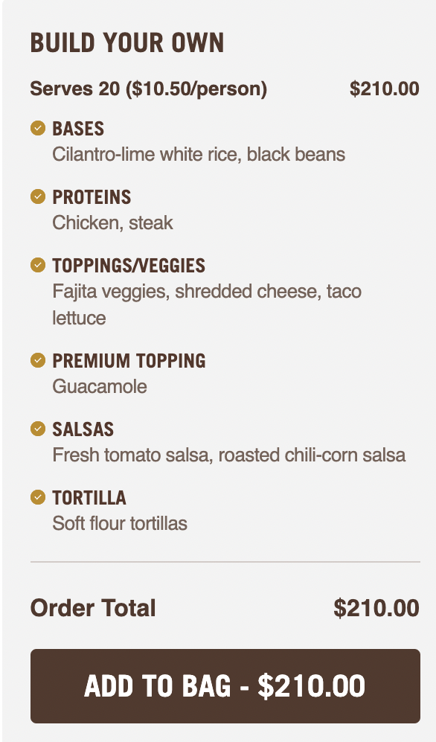  - 10 people: $105  - 15 people: $175.50  - Chick-fil-a  - Nugget Tray  - Medium: 120 nuggets, serves 15. $56.50  - Large: 200 nuggets, serves 25. $94.00  - Fruit Tray  - Small-Serves 12. $30.50  - Large-Serves 26. $61.50  - Publix  - Deli popcorn chicken platter  - $47.99 serves 28  - Deli all american platter, large  - $59.99 Serves 28  - Deli Finishing touch platter  - $19.99 serves 10  - Based on price and number of people we can serve, everyone agreed to order from Publix in order to have enough food while also accommodating to those who are vegan, have food allergies, etc.  - We can also store food in the fridges on the fourth floor of CON so we are able to pick it up earlier in the day since we will all be in class right before the meeting  - Vanessa will start to advertise 2 weeks prior to the meeting and include a google form to get an idea of how many students plan to come so we can get an estimate of how much food to order  - SNA Points  - Points up to date  - Future Guest Speakers  - Mary Nelson BSN, RN, CCRN  - ECMO Nurse
Treasurer:  Monique Csenteri | - Current Balance: $18,364.08  - Current Membership Count: 187  - Tax update:  - It has been a struggle finding everything Mr. Scott requested from me regarding the last 4 years of revenue and expenses. I am currently waiting on a response from him. My goal is to have our taxes finished before the semester starts.  - Membership renewal for board members:  - Sarah Stukey (3/11/22)  - Peyton and Cynthia, I will be calling you guys to receive payment within the week.  - Friendly reminders:  - All board members must sign the last page of the bank statement, financial report, and Venmo report. They are available for June and July! Please have these signed by 08/04/2021 @ 2359.  - June Financial Report:  - https://drive.google.com/file/d/1UokoeWvQalVFoYsc2IsioVPRPQkGZPCV/view?usp=sharing  - June Bank Statement:  - https://drive.google.com/file/d/189YwGW1Pl6vrP7prAFvH3aTMN4WYfrwn/view?usp=sharing  - June Venmo Report:  - https://drive.google.com/file/d/15Ms1ugPCWYodIAbuEyHQQe_4h95Hccd6/view?usp=sharing  - Sam, Megan, Alex, and Erin have not signed the above June Reports.  - July Financial Report:  - https://drive.google.com/file/d/1XOeq-r9zkqNh2gZcaTVVHZ8ek9yeTiMi/view?usp=sharing  - July Bank Statement:  - https://drive.google.com/file/d/10Crq4Bu03T0pkh8KMgSchRalki-GlPb6/view?usp=sharing  - July Venmo Report:  - https://docs.google.com/spreadsheets/d/1HTW-Iwm5t-UvP_n4bZ5OeiuQtZVTEhQbsWSxyAcPg-I/edit?usp=sharing  - Receipts:  - June: https://drive.google.com/drive/folders/1TRwFCEpesB7qMi3MhCVz1h-Dsu0WdfbM?usp=sharing  - July: https://drive.google.com/drive/folders/1VhAVea2d77VuzhSvPwG4B704WfrF1g49?usp=sharing  - 2 officers at the cash box at all times  - All officers can accept membership forms  - Must provide a receipt to get reimbursed  - Encourage Membership all you can!  - Bank Card must be signed in and out in order to use it  - EVERY purchase made with the SNA card REQUIRES a receipt to be sent to the treasurer within 48 hours of purchase  - Future plans:  - Working on contacting all members with soon to be expired memberships to discuss renewal.  - State convention is October 21-October 23. I am currently working on an interest form that I would like to have posted for our August general meeting. Do you guys think stopping the interest forms on September 16 would be enough to get the word out? I would like to have hotels booked by the end of September at the latest.  - As soon as FSNA post more information we can start to send our information and interest forms  - I do not see any prices up for the state convention yet or an official address.
Secretary:  Caroline Porter | - Next CC meeting TBD  - I will make the Kahoot game for next meeting and include the rationales with the answers because everyone really seemed to enjoy that  - I have updated the google calendar and the board contact list  - Emily please create a new Gmail for the accelerated liaison position and upload it to the contact list google doc found on our Facebook group page  - We need to vote to approve June’s board meeting minutes that can be found on the Facebook page  - Need to have minutes posted to our website  - Was looking over the bylaws and noticed in Article IV sec 1-B and in article VIII Sec 1-D it states the accelerated liaison does not have voting Privileges.  - Not sure if I’m the only one who didn’t know this or if we wanted to change this? Mainly just wanted to bring it up to make everyone aware and for documentation purposes in the minutes because I know we need a specific number of voting board members at emergency meetings in order to hold a vote |  |  | - Need to hold a vote to approve the June board meeting minutes.
Legislative Director:  Lauren Fuller | - FNSA Convention dates posted - Thursday 10/21-Saturday 10/23  - Will be held here in Orlando at the Doubletree  - No info yet on cost or the itinerary. Once that has been announced I will start the SGA funding request.  - Resolutions  - If you are interested in preparing a resolution please reach out to me!  - Resolutions are usually due in October, but it would be good to aim for finishing in September before classes pick up.  - Potential review of the Bylaws? If there is anything specific that you believe should be discussed or amended please make a note of it for the next board meeting! |  |  | - Need to confirm with SGA that we can request funding twice before we request it so that way the funds are put toward the more expensive trip which would be national convention.  - Need to amend bylaws in regards to our previous vote that if our organization was to be dissolved we would donate our funds directly to UCF’s College of Nursing.  - Look at amending bylaws about top 3 point earners and adding clarity to if they should be awarded a cord if they have been decelerated.
Clubhouse Director:  Alexandria Moran | - Helped to distribute the last summer merchandise orders  - Began re-organizing the clubhouse room  - Started looking into how to create a shipping option for any online merchandise orders  - We will be selling merchandise at the recognition ceremony tomorrow August 4th.  - If we run out of sizes we will take their name and contact information down and reach out to them about available merchandise later if we have more stocked in the clubhouse after the event.
Accelerated Liaison:  Emily Jones | - Created new email for position & updated contact sheet  - Contacting the director (Christina Gonzalez) for the Alumni Mentorship Program?  - Discussed w/ Megan that this was part of my responsibilities  - Emily will also help with the promotion of this program among the Accel cohort.
Media Director: Sarah Stukey | - Deadline to submit for the Lifeline Newsletter is September 19th!  - All officers will submit an article for this edition  - Email final submissions and any questions to me at ucfsnaorlwebmaster@gmail.com  - Please continue to submit nominations for both student and faculty spotlights for upcoming newsletters!  - I am currently communicating with the UCF Marketing team to get in contact about how to speak to Darin Edwards or reiterate his previous interviews for the Newsletter (Recommended by Mrs. Dorminy)  - Back to School BBQ planning with Cynthia! Tentative date would be August 30th, details below
Historian:  Cynthia Fonseca | - I had a great time attending the alumni board retreat last week getting to know some fantastic alumni and learning more about the alumni association!  - Special shout out to Mrs. Dorminy who led the retreat :)  - I plan to work hard to keep the alumni up to date on everything SNA related and vice versa and I look forward to helping strengthen the connections between the alumni and SNA/current students!  - Alumni mentorship program-is this something that I can/should be advertising to seniors and accelerated students?  - Yes, this is something that we can help promote through SNA to the senior nursing students.  - Back to School BBQ!!  - Monday August 30th (preferably) or Wednesday September 1st at 1700  - Everyone agreed August 30th would be the preferred date  - Tropical Smoothie patio with room 602 as a weather backup  - Classic BBQ food-can we use SNA card to purchase?  - Yes, the card can be signed out for the purchase of the food.  - Need help thinking of activities!! I have a UCF cornhole that I can bring from home and I want to do a raffle but I’m not sure if we should do anything else  - Is there anything we could get from the clubhouse to use in the raffle?  - Cynthia will coordinate with Alex about finding extra items from the clubhouse to use.  - I really want to do something special to honor Mrs. D like we did at the kickball game but I want it to be something unique/different-ideas are welcome!!  - Idea to plant her favorite flower/plant and have students/faculty sign the pot to keep there at the CON as a daily reminder of her.  - Does SNA have a grill? And do we need permission to use a grill on the patio?  - Grill is located on CON 4th floor patio, needs to be checked out to make sure it works prior to day of event.  - Best option may be to precook the food and use sternos to keep it warm  - Price for admission-$5 in the past for non SNA members/faculty, and should we include the raffle with admission or charge separately?  - Use 2 different colors tickets, one that indicates food and the other that indicates the raffle  - Should have a color system of some sort that also indicates which cohort students are in (i.e. different color name tags, cups, etc.)  - Could/should we invite alumni?  - Not really a lot of space so need to keep that in mind, faculty is already invited so considering the time and current situation may not be the best event but is a good for future events.  - May just want to invite past SNA board members. Cynthia will work with Dr. Peach to reach out to some of them that he is still in contact with.  - Myself and Sarah are going to create a task list for all of the officers to allocate responsibilities for the day of! I was thinking Monique and someone else will handle the cash box and membership applications but if anyone else wants to do anything specific let me know! We will need people handling the food, raffle, etc. Also, if you guys are willing to bring coolers, ice, decor, speakers, games/activities, etc. let me know!  - If you have any thoughts/comments/questions feel free to let myself or Sarah know! I am so excited about this event and want to make it as enjoyable and successful as possible :)
Breakthrough to Nursing Director:  Samantha Maiolo | - Emails are sent out to Guidance Counselors!  - Reply from Seminole High School - planning details to attend HOSA meeting  - Reply from University High School - counselor is looking into visitor policies  - B2N Committee? One of the previous directors had left a note saying I was able to organize a committee to help collaborate on events at schools. They mentioned needing a certain number of committee members in order to be considered a Diamond Chapter?  - Is there somewhere I can look to find clarification on this?  - It is at the boards discretion to create committees, it was agreed that it is well in Samantha’s prerogative to establish a committee if she would like to.  - Committee members must be paid SNA members, there is no cap on the number of members that can be on the committee  - The bylaws do indicate that there must be a vote among all SNA members to approve the chosen committee members  - Can group this vote in with the September board meeting election. Have those interested give a one minute speech as well and then have the SNA body vote along with the preliminary election.
Community Health Director:  Peyton Hawks | - I am now registered as a coach for the AHA heart walk on Saturday, November 13th! Let me know if you want to be a part of the walk so I can register you on my team.  - I’ll be posting a fundraiser on Facebook soon for the walk, please encourage friends and family to donate, thank you!!  - The Senior Citizen Connection Program just ended last weekend and it went great! I heard a lot of the residents still want to keep in touch with the students throughout the year :) Sarah- If you have any feedback on the program let me know!  - August Volunteering  - Straight Street on Tuesday, August 31st 5pm  - Habitat Restoration with Oakland Nature Preserve on Saturday, August 21st 8am  - Dr. Peralta asked if SNA wants to do a volunteering activity before the UCF football games. It’ll include fans using drunk driving goggles, playing games on football nutrition, doing BP/health checks, and encouraging non-alcoholic hydration.  - Which date(s) would you guys like to do?  - 10/9 (Saturday), 10/22 (Friday), 11/6 (Saturday) and 11/20 (Saturday)  - Going to hold off until after we get our exam schedules so that we can pick a good date and maximize the number of volunteers that sign up  - Gift of Life Marrow Registry wants to work with UCF College of Nursing this fall to set up a bone marrow donation drive to find matching donors for patients battling leukemia, lymphoma and other genetic disorders. Is this something you guys are interested in so I can go forward with setting it up??  - Peyton is going to move forward with setting this up.
Fundraising Chair:  Megan Fleming | - June Fundraiser  - Excited to say we made $71 off of the Chop 5 partial proceeds  - July Fundraiser  - We sold yard signs and made $66.88  - August Fundraiser  - Selling “Hugs from Home” packages to parents of the junior class as a surprise for their students starting nursing school  - They will cost $15 per goodie bag and will contain: candy, tea/hot chocolate, hand sanitizer, pen, mini notebook, popcorn, and granola bars  - Have bags purchased before ordering the supplies  - They will be delivered to students during the first few weeks of classes  - They will be advertised to parents through orientation and sold virtually through a google form  - I thought it would be best to advertise them during parent’s orientation and then if parents are interested in buying one then they add their name to an email list I will use to send them the form link?  - Last year Hope said she advertised it at orientation and then a follow-up email was sent out to parents by faculty, but I know I’ve already asked about contacting parents and having their emails and was told we don’t have access to that so does anyone know how she had access to them?  - Not sure how and if Hope ever had access to the list. Best idea was to have parents sign up for a mailing list after the parent orientation if they would like to receive emails from SNA about events/fundraisers.  - The only problem I’m having is advertising fundraisers to parents. I think fundraisers would be much more successful if we were able to reach them.  - Is there anything I am able to get from the clubhouse to include in the hugs from home packages? Like are there any left-over stickers or water bottles that could be included in the goodie bags?  - Alex and Megan will work together to see if there is anything from the clubhouse that is “extra” we can use in the goody bags. Megan will also reach out to Leah to see if she did write offs for stuff used in giveaways in the past.
Advisors:  Kate Dorminy  Brian Peach | Dr. Peach:  - Amendment Changes  - Amendments have to be voted on by the membership, not the board.  - Resolutions  - Writing a position statement about an issue you are passionate about that this organization believes needs to be changed in the clinical practice, that will be taken to state convention which will then be voted on to take to the national convention.

